Monday | Art  L.O: To sketch the other half of a photo.  Take a photograph of yourself or an object you have at home.  Fold the photograph in half and sketch out the other half. Mark out where the eyes, nose, mouth, chin, hairline etc would start.  Once you have finished, add a colourful background.  Examples  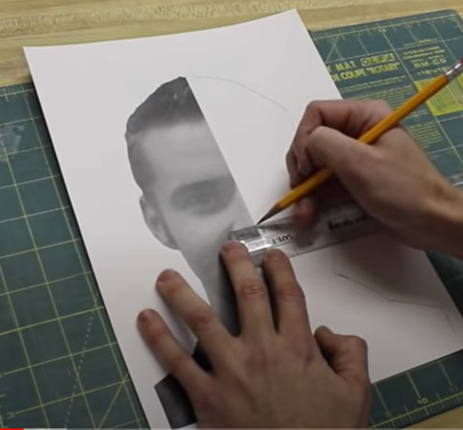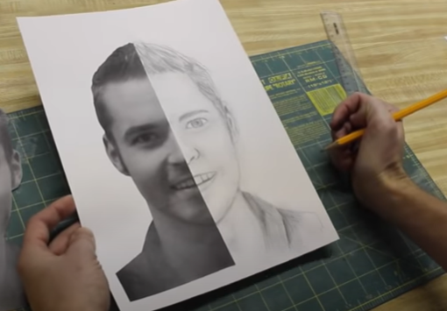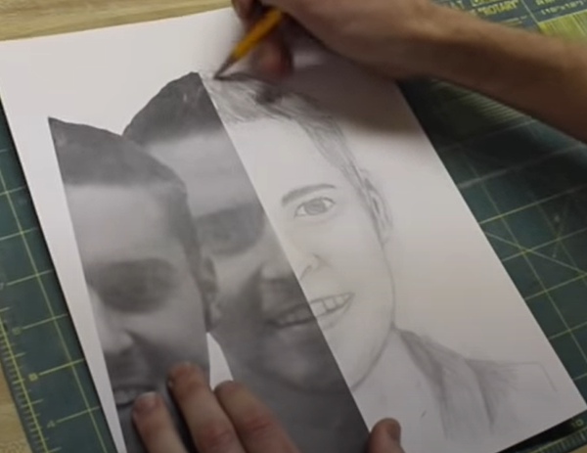
Tuesday | Science  L.O: to build a free standing tower using just two materials.  Recap: What is an engineer from previous lesson.  Question: How can you use two different materials to build the tallest freestanding tower?  Plan and label your design. What materials will you use? What design will work best?  Build a freestanding tower.  Evaluate your design.  Extension: add one more material to your towers.  Questions to consider:  What do Engineers do?  What do you think Engineers have to think about when they are designing and building structures like towers?
Wednesday  iPads | L.O: To research West Africa creating a fact file.  Linking to our Literacy text, The Blind Man and the Hunter, research West Africa and create a fact file.  You could use some of the following subheadings to help you:  Flag, capital, population, language, money, location, mountains, natural disasters, people and culture, food and diet or nature (animals and plants).
Thursday | RE  L.O: What does belief mean to you?  Christians believe that Jesus died, rose again and is now in heaven. Now it’s your turn to think about belief.  - What does the word belief mean?  - What sorts of things do people believe in?  - How do people show their beliefs?  - Is it easy for people to show their beliefs?  - Is it ever right to hide your beliefs?  - How should you treat someone who has different beliefs to your own?  Your task  Write a 30 second speech about something you strongly believe in, such as animal rights, free sports activities for schools, your faith or something totally different! Deliver your speech confidently and listen carefully to others. After the speeches, decide ‘Does everyone believe in the same thing?’ and ‘Is it ok to believe different things?’
Friday | Topic  L.O: To understand how mountains are formed.  Note: There are five major types of mountains: fold, fault block, volcanic, dome, and plateau mountains.  https://www.bbc.co.uk/bitesize/topics/z849q6f/articles/z4g3qp3 (What are mountains?)  https://www.youtube.com/watch?v=S9ty-ta1wyI (mountains, volcanoes and earthquakes)  https://easyscienceforkids.com/all-about-mountains/  Create a two page spread with pictures and information about the 5 types of mountains.  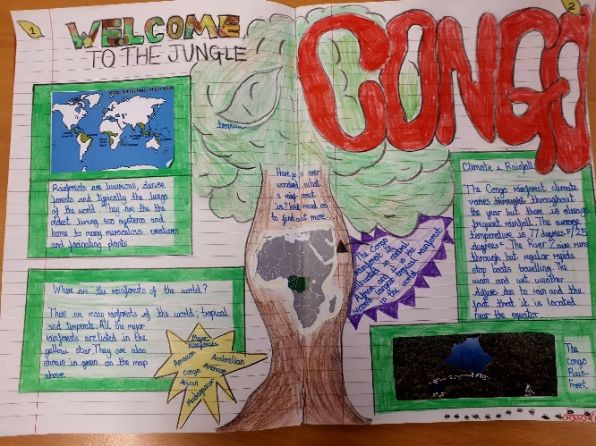  PE  Try a Joe Wicks workout  https://www.youtube.com/user/thebodycoach1  Standing long jump  Children will need 5 different cones each.  Must land with feet together  Children can run up before they jump. They can only do 5 strides. Introduce what strides mean. Get children to explore consistency and ensure they always jump before their cone and never over it. Make them aware that if they run past the cone it’s a ‘no jump’.

