Monday | Create Funky Bunny artwork  Using different patterns and lines fill in your Easter bunny. Carefully cut out the bunny and select a pair of sunglasses. Using watercolours or pastels, design and brightly coloured background then layer the bunny and sunglasses over the top.  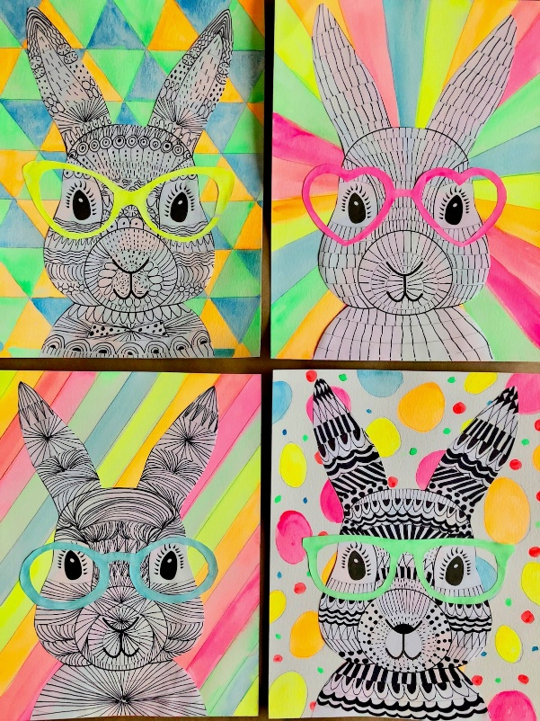  Watch Newsround  https://www.bbc.co.uk/newsround/news/watch_newsround
Tuesday | Watch short clip about Good Friday and Easter Sunday  https://www.bbc.co.uk/teach/class-clips-video/religious-studies-ks2-easter/znkngwx  Look out for the following symbols. 1. The fire burning on Easter morning 2. Touching the stone where Jesus fell 3. Hot crossed buns 4. The Easter egg 5. The chicken born from the egg.  Think about what each of these things mean and write your answers in the display bubbles on the worksheet.  PSHE  The way we play/friendship  Think carefully about something you really enjoy playing (football at school). What can you do to make sure everybody has a good time?  Working with your partner, discuss the scenario cards.  Watch Newsround  https://www.bbc.co.uk/newsround/news/watch_newsround
Wednesday  iPads | QR Easter egg hunt  Watch Newsround  https://www.bbc.co.uk/newsround/news/watch_newsround

