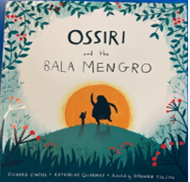
Friday 15th January 2021
Reading Comprehension
Text- Ossiri and the Bala Mengro pg 19 – End of story

- Why was Ossiri shocked that the Bala Mengro (ogre) wanted her to play again?

- How do you know the ogre enjoyed the music?

- What did the Bala Mengro give to Ossiri after she played her instrument?

- Why did the stranger want to play music for the Bala Mengro?

- Why did the Bala Mengro like to listen to Ossiri play and not other people?

- What do you think happened to the stranger at the end of the story?

- Did you enjoy this story? Explain your answer.

