Year 2 Weekly Planning Overview
WC01.02.21
For additional information please use the resources and PPTs on the website and the daily Teacher input sessions.
Weekly Text – The Great Kapok Tree by Lynne Cherry
Subject | Monday 1st Feb | Tuesday 2nd Feb | Wednesday 3rd Feb | Thursday 4th Feb | Friday 5th Feb
Literacy 9:30am  (20 minutes) | LO: To match a description to an animal.  Match the mystery animals to the pictures. After that,  choose your own rainforest creature and write a description for someone else to guess what it might be. | LO: To write a diary from the viewpoint of the Kapok Tree.  Look at the example diary given and think about what the tree might see/hear/feel while it stands in the forest. Use prepositions from last week to describe where things are. | LO: To create a persuasive poster  Look at the reasons the animals gave the man. Make a poster to persuade others to protect the rainforest.  Option 1 – Use speech bubbles to complete the poster template either by writing or typing on the sheet.  Option 2 – Create an original persuasive poster (See PPT for ideas) | LO: Reading Comprehension  Read the PPT and non-fiction text and answer questions based on given on rainforests. The level of difficulty is signified by the number of stars at the bottom of the page. The more stars the greater the challenge. | LO: To use adverbs  Look at PPT and think about the verbs (doing words) that match the animals. Children write in the adverb to suit the movement.  Write your own sentence about a chosen animal including a verb and adverb.  Opt 1 – Write directly onto printed sheet.  Opt. 2 – Type onto word template.  Opt. 3 – Write sentences on a piece of paper.
Maths  11:00am  (15 minutes starter activity) | LO: To draw and interpret Block Diagrams.  Starter: Maths warm up/Problem solving with Miss King(Live lesson)  Independent Task -Work through PowerPoint or video for this lesson.  Next complete:  Option 1 – Worksheet  or  Option 2 – Practical task  Use Smarties to represent data you have collected.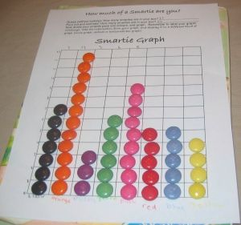 | LO: To draw and interpret Block Diagrams.  Starter: Maths warm up/Problem solving with Miss King(Live lesson)  Independent Task -Work through PowerPoint or video for this lesson.  Next complete:  Option 1 – Worksheet  or  Option 2 – Practical task  Find different criteria to sort objects in your house. You could even tidy up by sorting objects into the room they belong in.  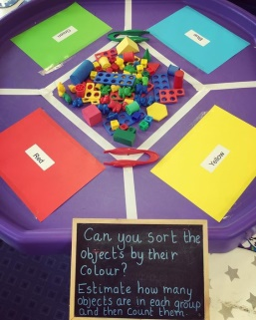 | LO: To assess your knowledge of Tally Charts, Pictograms and Block Diagrams.  Starter: Maths warm up/Problem solving with Miss King(Live lesson)  Independent Task –  Revise knowledge of statistics.  Option 1 – Worksheet  or  Option 2 – Practical task  Make a tally of the objects you find outdoors. You could use the data to make pictograms and Block Diagrams.  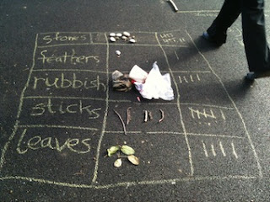 | LO: To understand how to use Carroll Diagrams.  Starter: Maths warm up/Problem solving with Miss King(Live lesson)  Independent Task –Read the story (Starry Eyed Stan) to accompany the Carroll Diagram task.  Next complete:  Option 1 – Worksheet  or  Option 2 – Practical task  Make a Carroll Diagram using objects at home. Pupils to choose the criteria they use to sort the objects.  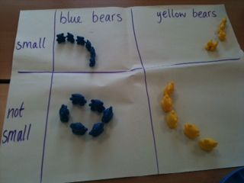 | LO: To apply knowledge of statistics to solve problems.  Starter: Maths warm up/Problem solving with Miss King(Live lesson)  Independent Task –Revise what you have learnt about Statistics so far.  Next complete:  Option 1 – Choose some statistics challenges to complete.  or  Option 2 – Practical task  Use big hoops or ropes to sort objects using a Venn Diagram  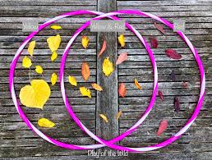
Numeracy Extension/ Challenge | Complete the Statistics Challenge cards.
Topic  Independent Projects | Monday: Topic focus work 1 Decorate a tribal stick based on those used in the Amazon Rainforest. (See PPT)  Tuesday: Topic focus work 2. To learn about the history of chocolate & create a delicious chocolate dish. (See PPT)  Wednesday: Science – Every Day Materials – To describe materials based on their properties (Waterproof Test). (See PPT and worksheet)  Thursday: Geography- Find out about the different layers of the rainforest. (See PPT)  Friday: PSHE-Children’s Mental Health Week – Pupils to make a mental health tool kit. (See PPT)  PE – Joe Wicks – Take part in one of Joe’s workouts or create your own tribal dance.
2;00pm | Review of work achieved, Talk and Tell or Story

