Year 1 Weekly Planning Overview
WC01.03.21
For additional information please use the resources and PPTs on the website and the daily Teacher input sessions.
Weekly Text – The Sword in the Stone
Subject | Monday | Tuesday | Wednesday | Thursday | Friday
Literacy 9:30am  (20 minutes) | LO: To describe a setting in detail  Look at the picture of the snowy scene and describe it using powerful adjectives. Think about the things (nouns) you can see and write about each clearly.  Write about who you think the man is and why he has a baby.  Opt. 1 – Print out template and write your description.  Opt. 2 – Write up your description on a piece of paper. | LO: To create a poster to publicise the hunt for the new king of England.  Think about how the tournament was going to be advertised to the knights. Include the year e.g.1138 where it is e.g. The Abbey and what the tournament would entail e.g. Jousting / sword fighting etc.  Think about the qualities needed in a King.  Opt. 1 – Use the example and type in your own text.  Opt. 2 – Create your own poster on a blank piece of paper. | LO: To write a diary of the day Arthur discovered he was king.  Remember the format of a diary. Write in first person and include time conjunctions and in the past tense. Include what he did and how he felt.  Opt. 1 – Type up on word.  Opt. 2 – To handwrite your own diary on paper.  You could make it look old by adding tea stains to it and ripping the edges. | LO: WORLD BOOK DAY!  Activity 1 – Create a cartoon strip to show dialogue between 2 book characters.  Activity 2 – Film the dialogue.  Activity 3 – Create a scene from your favourite book.  See PPT and video for ideas. | LO: SPAG To ask and answer questions to King Arthur.  Think about what you would like to ask King Arthur as he starts his new reign. Write your questions using question words and correctly formed question marks.  Think about how he would respond to those questions.  Opt – 1 Type your questions onto Word and add in the responses he would give.  Option 2 – Handwrite your questions and responses on paper.
Maths  11:00am  (15 minutes starter activity) | L.O. Sort 3D shapes.  Independent Task -Work through PowerPoint or video for this lesson.  Next complete:  Option 1 – Worksheet  or  Option 2 – Practical task  Group 3D shapes you find around the home. How are the shapes the same? How are the shapes different?  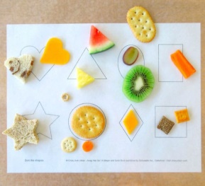 | L.O. Make patterns with 3D shapes.  Independent Task -Work through PowerPoint or video for this lesson.  Next complete:  Option 1 – Worksheet  or  Option 2 – Practical task  Build a model using 3D shapes you find at home. What shapes were needed? Can you name all 3D shapes used and their properties?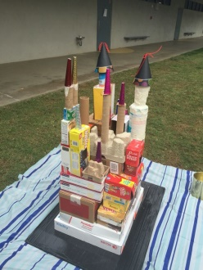  Castle | L.O. Make equal parts.  Independent Task -Work through PowerPoint or video for this lesson.  Next complete:  Option 1 – Worksheet  or  Option 2 – Practical task  Do some cooking. Can you cut food into equal parts? E.g. Can you make sure everyone has an equal sized slice of pizza, cake or apple?  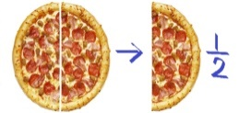 | L.O. Recognise a half.  Independent Task –Work through PowerPoint or video for this lesson.  Next complete:  Option 1 – Worksheet  or  Option 2 – Practical task  Can you create a half picture where half of the drawing is one colour and the other half another colour? Use a ruler to carefully find out where to split the picture into 2 halves. You could create butterflies, T-shirts designs, flowers it’s up to you.  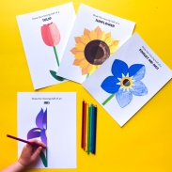 | L.O. Find a half.  Independent Task -Work through PowerPoint or video for this lesson.  Next complete:  Option 1 – Worksheet  or  Option 2 – Practical task  Practise sharing objects to make 2 halves. E.g. Play snap. Make sure you and the person you are playing with have the same number of cards or you could share a packet of sweets or crayons with someone.  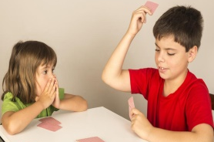
Numeracy Extension/Challenge | Complete the fraction word problem challenges.
Topic  Independent Projects | Monday: Topic - History – Create a poster fact file about King Henry VIII  Tuesday: D&T/ History -To explore Tudor recipes and create your own Tudor dish.  Wednesday: Science Investigation - How do Germs Spread?  Thursday: WORLD BOOK DAY - Create your own Scene from your favourite book. Use ANY medium at all i.e. shoe box scene / Minecraft / Lego / Duplo / Painting / Pictures / Your own toys and bricks. Whatever you want! Send us your scenes!  Friday PSHE: Friendship – ‘Meesha Makes Friends’ book activities.  PE – Joe Wicks – Take part in one of Joe’s workouts.  Cosmic Yoga
2;00pm | Review of work achieved, Talk and Tell or Story

