Friday 26th March 2021 LO: To answer questions about the events in the story
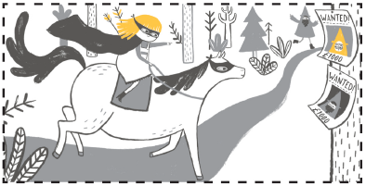
Where was Rapunzel going in this picture?
______________________________________________
______________________________________________
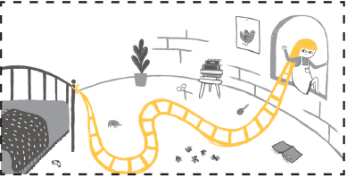
______________________________________________
How did Rapunzel get out of the tower?
_______________________________________________
_______________________________________________
_______________________________________________
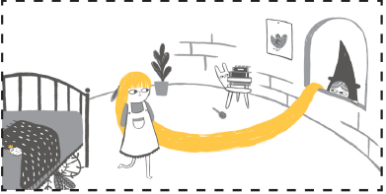
Why did the witch thing Rapunzel left her tower?
_______________________________________________
_______________________________________________
_______________________________________________
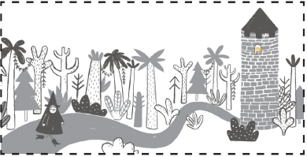
Where is the witch going?
_______________________________________________
_______________________________________________
_______________________________________________

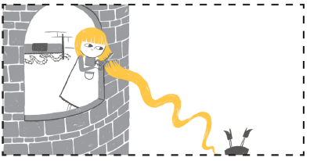
Why did Rapunzel cut her hair?
_______________________________________________
_______________________________________________
_______________________________________________

