1901 Queen Victoria dies.  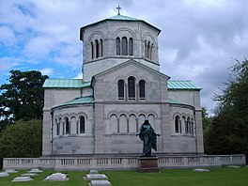 | 1857 Victoria gives birth to the last of her 9 children.  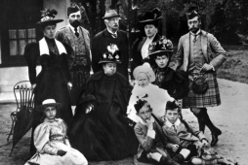 | 1819 Queen Victoria is born.  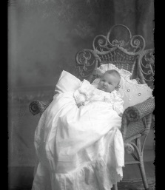 | 1840 Queen Victoria marries Prince Albert.  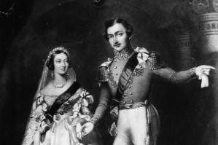 | 1837 Victoria is crown Queen.  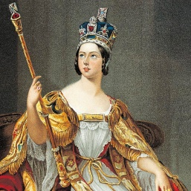

1901 Queen Victoria dies. | 1857 Victoria gives birth to the last of her 9 children. | 1819 Queen Victoria is born. | 1840 Queen Victoria marries Prince Albert. | 1837 Victoria is crown Queen.

