Year 2 Weekly Planning Overview
WC18.01.21
For additional information please use the resources and PPTs on the website and the daily Teacher input sessions.
Weekly Text – A Day and Night in the Amazon Rainforest – Caroline Arnolds
Subject | Monday 18th | Tuesday 19th | Wednesday 20th | Thursday 21st | Friday 22nd
Literacy 9:30am  (20 minutes) | LO: Timeline of the Amazon Day  Share the text to p.20. Look at the text and complete the fact boxes on the timeline to explain what happens during different times in the rainforest. I would aim to complete 6 fact boxes.  Option 1 – Print of sheet.  Option 2 – Complete in PowerPoint.  Option 2 – Draw own timeline on paper. | LO: Create a Fact File  Read up to p.20 and choose your favourite animal.  Create a fact file based on the given template.  Opt. 1 – Print off sheet complete with facts.  Opt. 2 – Create your own PowerPoint fact file.  Opt. 3 Create your own fact file on paper. | LO: Create a Poem about the Rainforest  Watch a Youtube video of rainforest  https://www.youtube.com/watch?v=3vijLre760w  Create a poem about being in a rainforest. Think about the things you would see/hear/smell/taste/touch  Opt. 1 – Acrostic Poem  Opt. 2 – Shape Poem  Opt. 3 – Freeverse poem | LO: Reading Comprehension  To answer questions based on the text in the book.  Opt. 1 – Print off and complete questions on the sheet.  Opt. 2 – Type in word.  Opt. 3 – Write answers on paper. | LO: SPAG  Past / Present Tense.  Adapt given sentences into either present or past tense.  Opt 1 – Write directly on to sheet.  Opt. 2 – Type in word.  Opt. 3 – Write answers on paper.
Maths  11:00am  (15 minutes starter activity) | LO: Use and apply the 10 times table.  Starter: Maths warm up/Problem solving with Miss King(Live lesson)  Independent Task -Work through PowerPoint or video for this lesson.  Next complete:  Option 1 – Worksheet  or  Option 2 – Practical task    With a partner each player shows a number of fingers on the count of 3 (similar to rock, paper, scissors). The first person to multiply the 2 numbers represented is the winner. | LO: Make equal groups- Sharing.  Starter: Maths warm up/Problem solving with Miss King(Live lesson)  Independent Task -Work through PowerPoint or video for this lesson.  Next complete:  Option 1 – Worksheet  or  Option 2 – Practical task  https://www.youtube.com/watch?v=op-Qyt7Hm98&feature=emb_logo Practise division using Lego. Use the video link above to show you how to do this. | LO: Make equal groups – Grouping,  Starter: Maths warm up/Problem solving with Miss King(Live lesson)  Independent Task –Work through PowerPoint or video for this lesson.  Next complete:  Option 1 – Worksheet  or  Option 2 – Practical task  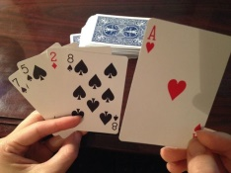  Give “Go Fish” a division spin! Instead of looking for matching pairs, players compete to find pairs of cards that divide evenly into each other. For instance, in the hand shown, the player could lay down the 8 and the 2, because they divide to make 4. | LO: Divide by 2.  Starter: Maths warm up/Problem solving with Miss King(Live lesson)  Independent Task -Work through PowerPoint or video for this lesson.  Next complete:  Option 1 – Worksheet  or  Option 2 – Practical task  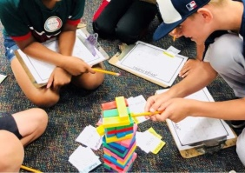  Write division sums on different coloured cards. Next colour code Jenga blocks using a coloured dot sticker or a felt pen dot to match the colour of the cards. Children have to answer the sum on the card and remove a Jenga block from the stack ensuring the colour of the card matched the colour of the block. | LO: Use odd and even numbers.  Starter: Maths warm up/Problem solving with Miss King(Live lesson)  Independent Task -Work through PowerPoint or video for this lesson.  Next complete:  Option 1 – Worksheet  or  Option 2 – Practical task  https://youtu.be/XT9aqgpjdyw - Watch the video above to learn about Odd Todd and Even Steven.  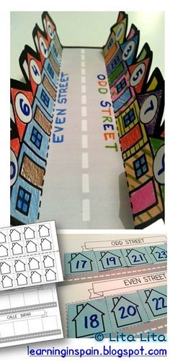  Make Odd Todd’s and Even Steven’s street as shown in the photo above.
Challenge/  Extension | Complete the division and multiplication word problems. (See website for questions)
Topic  Independent Projects | Topic focus work 1. Art – Create a work of art inspired by Henri Rousseau. (See PPT)  Topic focus work 2. Music - Compose your own samba rhythm. (See PPT)  Science – Every Day Materials – To describe materials based on their properties.  3A Easy 3B Medium 3C Hard (PPT and worksheet)  PSHE-Watch the Thankful spot story. https://www.youtube.com/watch?v=GXUoQ5MugCY  Complete ‘ I am thankful for… activity’.(See PPT)  Geography- Compare Notting Hill and the Rio Carnival. (See PPT)  PE – Joe Wickes – Take part in one of Joe’s workouts.  Just Dance to Samba Music - https://www.youtube.com/watch?v=nbs79mpN73M
2;00pm | Review of work achieved, Talk and Tell or Story

