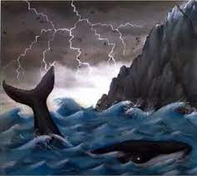
Wednesday 16th June 2021
LO: Use onomatopoeia to describe a storm (using sentence starters and word bank)
E.g. The whale’s tail smacked the water.



Snail Whale Waves

Lightning rocks sky

bang crash splash thud whoosh
boom smash pop splat scream

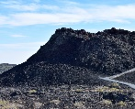

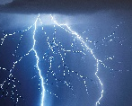

The waves ………………………………………………………………………………………………………….
…………………………………………………………………………………………………………………………..
Lightning filled the stormy sky and ………………………………………………………………………
…………………………………………………………………………………………………………………………..
The tiny snail ……………………………………………………………………………………………………..
…………………………………………………………………………………………………………………………..

