Year 2 Weekly Planning Overview
WC25.01.21
For additional information please use the resources and PPTs on the website and the daily Teacher input sessions. Weekly Text – The Invisible Lizard by Kurt Cyrus https://www.youtube.com/watch?v=It5MZHv2nGE
Subject | Monday | Tuesday | Wednesday | Thursday | Friday
Literacy 9:30am  (20 minutes) | LO: To use similes and adjectives  Read to P. 5  Think about where Napoleon might hide. Colour in the chameleon and describe how he looks using adjectives and similes. | LO: To think about a situation from the viewpoint of a character.  Read  P.6-P.11  Imagine you are Napoleon. What would you do to attract the attention of the other animals in the rainforest? Draw and write a plan. | LO: Talk about what you like and dislike about a book. Design a new front cover for a book,  Read to end of the book.  Design a front cover for the story ‘The Invisible Lizard’ and write a book review for the story. | LO: Reading Comprehension  Answer comprehension questions about ‘The Invisible Lizard’. | LO: SPAG  Using Prepositions  Introduce the concept of prepositions and get the children to use these words in a sentence to describe the position of Napoleon.
Maths  11:00am  (15 minutes starter activity) | LO: Make Tally Charts  Starter: Maths warm up/Problem solving with Miss King(Live lesson)  Independent Task -Work through PowerPoint or video for this lesson.  Next complete:  Option 1 – Worksheet  or  Option 2 – Practical task  Look out of your window. Make a tally chart by collecting information about what you can see e.g. car colours, birds, dog breeds, hair colour of the people you see.  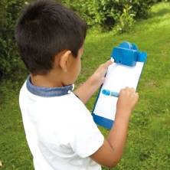 | LO: Draw Pictograms 1:1  Starter: Maths warm up/Problem solving with Miss King(Live lesson)  Independent Task -Work through PowerPoint or video for this lesson.  Next complete:  Option 1 – Worksheet  or  Option 2 – Practical task  Using the information you collected using a tally chart yesterday, draw pictures to create a large pictogram to represent the data. | LO: Interpret Pictograms 1:1  Starter: Maths warm up/Problem solving with Miss King(Live lesson)  Independent Task -Work through PowerPoint or video for this lesson.  Next complete:  Option 1 – Worksheet  or  Option 2 – Practical task  Make a pictogram using real life objects you find in your house. What number does each object represent? E.g. If making a pictogram about favourite fruit, one orange could represent 2 people. | LO: Draw Pictograms 2, 5 and 10  Starter: Maths warm up/Problem solving with Miss King(Live lesson)  Independent Task –Work through PowerPoint or video for this lesson.  Next complete:  Option 1 – Worksheet  or  Option 2 – Practical task  Using the information collected on Monday use Lego to make a block diagram.  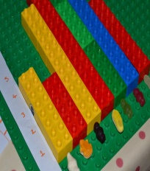 | LO: Interpret Pictograms 2, 5, 10  Starter: Maths warm up/Problem solving with Miss King(Live lesson)  Independent Task –Work through PowerPoint or video for this lesson.  Next complete:  Option 1 – Worksheet  or  Option 2 – Practical task  Find out more about a member of your family by creating a Venn Diagram. If it is something that only you like put it on your side of the diagram, if it is something only your family member likes put it on the other side of the Venn Diagram if you both like the thing then write/draw or put object in the middle of the diagram where the 2 circles cross over.  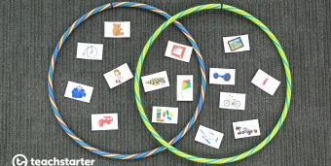
Maths Challenge/ Extension Activity | Complete ‘The Mystery of the Squashed Fruit’ booklet.
Topic  Independent Projects | Monday: Topic focus work 1. Design & Make a carnival headdress (See PPT)  Tuesday: Topic focus work 2. Design & label your own mythical creature / and/or create a fact file (See PPT)  Wednesday- Science – Every Day Materials – To describe why some materials suit different objects better than others.  4A Easy 4B Medium 4C Hard (PPT and worksheet)  Thursday: PSHE-Make a positivity poster with a message to share with each other. (See PPT)  Friday: Geography- Recognise landmarks in Brazil (See PPT)  PE – Joe Wicks – Take part in one of Joe’s workouts.  - Cosmic Yoga (Various videos YouTube)
2;00pm | Review of work achieved, Talk and Tell or Story

