Can I calculate division?
Ug might be a boy genius but he is in a division pickle! Can you help?!
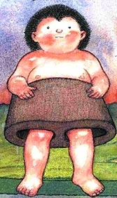
Can you divide 72 bits of cold meat between Ug, Ag and their 4 friends?

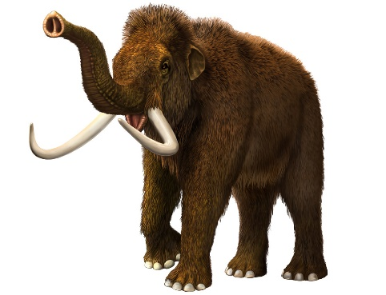

Ug is making another wall to keep the animals in. Can you divide 54 stones between 6 animal caves? How many stones are used to build each animal cave?

Ug uses 88 bits of stone to build 8 wheels. How many bits of stone for each wheel?


There are 112 flowers Ug picks for 8 people. How many flowers do they get each?

Ug tries to use 88 mammoth skins to make 4 pairs of trousers. How many mammoth skins does he use to make each pair of trousers?

Dug and Dugs and Ug want to share 84 tools with 6 friends. How many tools do they each get?

Can I calculate division?
Ug might be a boy genius but he is in a division pickle! Can you help?!
Can you divide 34 bits of cold meat between Ug and Ag?

Ug is making another wall to keep the animals in. Can you divide 48 stones between 3 animal caves? How many stones are used to build each animal cave?

Ug uses 69 bits of stone to build 3 wheels. How many bits of stone for each wheel?

There are 56 flowers Ug picks for 4 people. How many flowers do they get each?

Ug tries to use 42 mammoth skins to make 3 pairs of trousers. How many mammoth skins does he use to make each coat?

Dug and Dugs and Ug want to share 72 tools with 6 friends. How many tools do they each get?

Can I calculate division?
Ug might be a boy genius but he is in a division pickle! Can you help?!
Can you divide 12 bits of cold meat between Ug, Ag and their 4 friends?

Ug is making another wall to keep the animals in. Can you divide 20 stones between 10 animal caves? How many stones are used to build each animal cave?

Ug uses 12 bits of stone to build 6 wheels. How many bits of stone for each wheel?

There are 24 flowers Ug picks for 4 people. How many flowers do they get each?

Ug tries to use 32 mammoth skins to make 4 pairs of trousers. How many mammoth skins does he use to make each coat?

Dug and Dugs and Ug want to share 45 tools with 5 friends. How many tools do they each get?

