Friday 22nd January 2021
Task - Complete the sentence with the correct past or present tense verb.
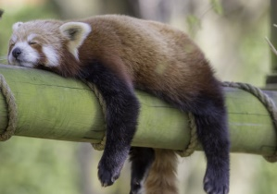 | Today the red panda is sleeping.  Yesterday the red panda___________.
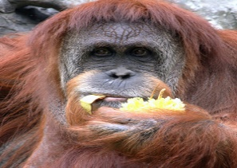 | Today the orangutan is ____________.  Yesterday the orangutan ate.
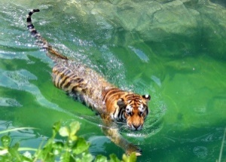 | Today the tiger is swimming.  Yesterday the tiger_________________.
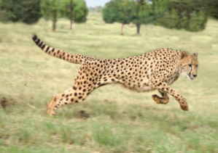 | Today the cheetah is ______________.  Yesterday the cheetah ran.
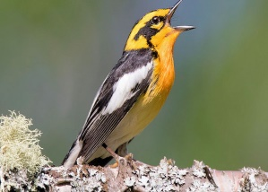 | Today the bird is singing.  Yesterday the bird ________________.
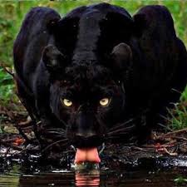 | Today the panther is _____________.  Yesterday the panther drank.

Challenge – Now write your own animal sentences using the past and present tense.

