What else can you think of that gives us clues about this character?
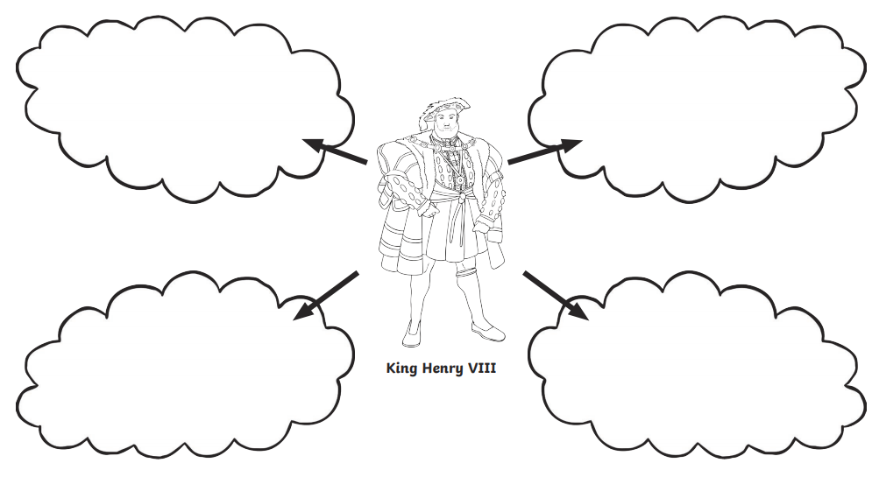
What do you think he does for a job?
What do you think of his clothes? What do they tell us?
Who do you think this character is?
Do you think he is from modern or historic times? Why do you think this?

