Weekly planning 4.5.20
English  1. Find out about medieval castle defences. Draw or print out a picture of a castle. Label and explain the function of each part of the castle.  2. Write a story about walking into a mysterious castle. Remember to describe the setting and the characters, include a dramatic event and explain what happens at the end of the story.  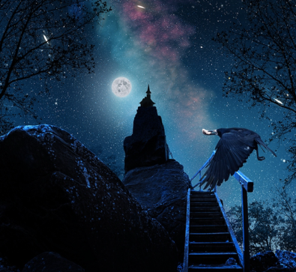  3. Use the word ‘rainbow’ or a word of your choice to write an acrostic poem about how you feel or the fun activities you have been doing at home with your family.  4. Look at the tower in the illustration.  - Would you go inside the tower to investigate? Explain your answer?  - Why do you think many spooky stories are set at night?  - What do you think the crow is carrying?  - Do you enjoy reading spooky stories? Explain your answer. |  | Maths  - Draw a symmetrical picture. Afterwards try to find objects or pictures of objects that are symmetrical?  - Look at patterns in nature e.g. snowflakes, snail shells, starfish. Are any patterns repeated?  - Continue to practise all times tables focusing mainly on the 2, 3, 5 and 10 times table.  - Make a calendar. Ensure the months of the year are in order. Can you draw a picture to show what events take place during each month?  - With your parent’s permission find some objects you can fill with water. Over the bath or shower, use your estimation skills to put the objects in order of the volume of water they can hold. Test your prediction either using a measuring jug or by pouring water from one container to another starting with the smallest. If the water overflows your prediction must be incorrect.
Science  Learn about the factors that affect plant growth by growing cress or beans on wet kitchen towel and place the seeds/beans in different areas of your house e.g. windowsill, fridge, dark cupboard. Which seeds grow and why?  Find out how plants get their water and nutrients by observing the roots of a bean grow in a transparent vase or place a white carnation in water and food colouring and observe what happens to the petals. (You could use other flowers if necessary) | Topic  Find out about famous towers around the world. Plot them on a world map.  P.E  Learn a new dance with KIDZBOP dance along on YouTube.  Be inspired by Captain Tom and keep a record of how far you walk either indoors or during your daily walk. If you had walked in a straight line where in the country could you have ended up? |  | Art/DT/Music  Find out how castles were built to defend the people living in it. Build a model of a fort/castle using household objects. Once you have made it test it using cannon balls made from used paper you are going to recycle.  Listen to some medieval music such as Greensleeves. Recreate your own medieval music using real or homemade instruments.
Our topic for this half-term is Tower, Tunnels and Turrets, some of the activities have been selected to introduce this. Websites you might find useful are on the Year 1/2 class page of the school website.

