BISHOPTON PRIMARY SCHOOL – WEEKLY LITERACY PLANNER

 | Term objectives: .  Class: Year 1  Week beg: 29.6.20  Teachers: EK, CC, JG, EH |  | ICT links https://www.youtube.com/watch?v=4pZwNie69n8 Superworm |  | Cross Curricular Links  Topic – Scented Garden
 | Phonics | Whole Class Word/  Sentence Work |  |  |  | Plenary
Mon |  | Don’t read the story yet!  Look at a worm – look at a picture/model or real one! How could we describe the worm? Can you write down as many words as you can to describe the worm. (e.g. slimy, wiggly, pink)  Think about your words. This is no ordinary worm – this worm is a Superworm! But when people look at him they don’t think of super words to describe him, they use boring words instead. Can we think of any new words to add to our list to make him sound more exciting and interesting to other people? Scribe down the ideas in a different colour and discuss the difference. |  | NC: To be able to think of words and sentences to make a creature sound exciting and interesting |  | Read the story of superworm do your words reflect how super Super-Worm really is?
Mon |  |  |  | To describe super worm using adjectives.
Mon |  |  |  | *4 initial adjectives then 4 super adjectives  **6 initial adjectives then 6 super adjectives  *** 8 initial adjectives then 8 super adjectives
Tue |  | Discuss yesterday’s work and what we did to describe the worm.  On your paper draw a picture of a worm and think about how they can make the worm sound really interesting and exciting to another person. Put these words into a sentence e.g. ‘Superworm is...’ and write them neatly using and to connect ideas.  Eg.  Superworm is.... __________________ and _________________.  He has ___________________ skin and ___________________ eyes.  His skin is pink as a ________________. (Add in a simile or two if you can!) |  | NC Year 1- To be able to think of words and sentences to make a creature sound exciting and interesting
  Say your some exciting and interesting sentences about Superworm. What do the adjectives do to your sentence?
Tue |  |  |  | To describe the worm you would feed to Jack.  To describe the food using adjectives/Similes.
Tue |  |  |  | *4 complete sentences using adjectives and punctuation.  **6 complete sentences using adjectives and punctuation.  *** 8 complete sentences using adjectives and punctuation.
Wed |  | Treasure Hunt!  Re-cap what we know about the story of Superworm. What does Wizard Lizard get Superworm to do? Read the mysterious letter from the resources. The letter will be from Superworm explaining that he has left some clues for them to follow and they may find some treasure.  This session will need parental support to hide ‘treasure’ for the child to find in specific places. The letter can be adjusted by a parent if some of the ‘locations’ don’t work for the child’s home! |  | NC Year 1- To take part in a treasure hunt reading a letter from superworm. |  | Can you come up with your own clues for where ‘treasure’ might be!
Wed |  |  |  | To read a letter from superworm and work out clues to find treasure.
Wed |  |  |  | This can be done as an optional lesson for your child to practice reading and work out clues.
Thu |  | Superworm is seen as a hero by his friends. He is a fishing line, a lasso etc. What other things could superworm do to be a hero? Look at the resource sheet for Thursday and the pictures. Cut out the picture and explain how Superworm might be a hero in this scene. Use adjectives and clear punctuation (capital letters and full stops). |  | NC Year 1- To write about how Superworm could be a hero in different situations. |  | Can you think how superworm might help you in everyday life!
Thu |  |  |  | Use speech bubbles to show what the characters say.  Use pictures to show the events. |  | Can you think how superworm might help you in everyday life!
Thu |  |  |  | Write about how Superworm is a hero in different pictures.  Add in speech bubbles to show what he and others might say. |  | Can you think how superworm might help you in everyday life!
Fri |  | Think about the story of Superworm. Think about your own ‘super insect’ and create a comic strip to show what he / she does to become a hero in the garden.  Include pictures, speech bubbles and sentences to describe what might happen in the comic. |  | NC Year 1- Write a comic strip based on your own ‘super-insect’ |  | Show your comic strip to a friend or family member. What do they think of your super insect?
Fri |  |  |  | Use adjectives to describe the nouns (fuzzy bee / pretty flowers)  Use clear capital letters and full stops.
Fri |  |  |  | Cartoon strip

Maths Planning WC29/6/20
Maths | Weblinks: White Rose Maths: https://whiterosemaths.com/homelearning/year-1/  BBC Bitesize Daily lessons: https://www.bbc.co.uk/bitesize/dailylessons
Lesson Objective: | Lesson 1: Ordering Numbers worksheet and video.  https://resources.whiterosemaths.com/wp-content/uploads/2020/06/Lesson-1-Ordering-numbers.pdf | Lesson 2: Recognising coins worksheet and video.  https://resources.whiterosemaths.com/wp-content/uploads/2020/06/Lesson-2-Recognising-coins.pdf | Lesson 3: Recognising notes worksheet and video.  https://resources.whiterosemaths.com/wp-content/uploads/2020/06/Lesson-3-Recognising-notes.pdf | Lesson 4: Counting in coins worksheet and video.  https://resources.whiterosemaths.com/wp-content/uploads/2020/06/Lesson-4-Counting-in-coins.pdf | Lesson 5: Friday Maths Challenge .
Optional resources for Classroom teaching | 100 sq grid on WB  Number lines on WB | Coin display resources | Notes display resources
Optional Additional Maths Task | 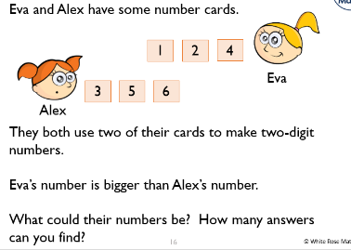 | 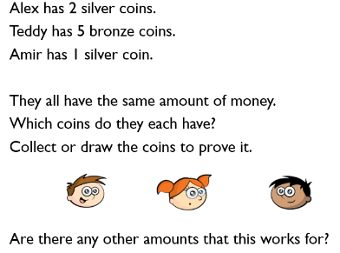 | 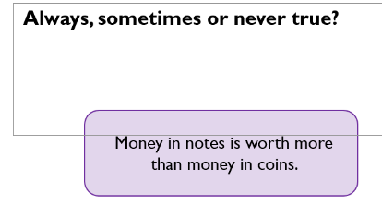 | 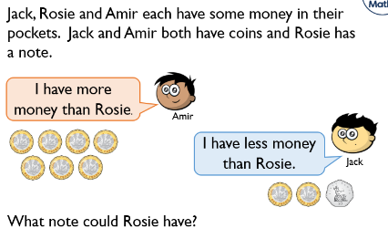 | How many Friday Maths Challenges can you do with your family?

Topic/Task Planning WC29/6/20
Foundation Subjects
Topic / Task:  These can be done in an afternoon or some may be spread over a couple of sessions. | Art Design a superhero costume for Superworm to wear.  What materials would you use? What colour? | Science: Can you sort the creatures into different groups?  How have you sorted them? Are there any similarities/differences? | Outside Go out on a minibeast hunt, what mini beasts can you find. Note them down, take pictures or draw them. (Sheet) | Science Choose one of the creatures from the story. Can you write information about it? Where does it live? What does it eat? | Science: Watch https://www.bbc.co.uk/bitesize/clips/zdp6n39 discuss food chains.  Create a food chain that includes some of the animals in the story.
Tasks that can be completed in the afternoon that may link to topic. | PE Can you move and replicate the actions of the creatures in the story? For example; Slither like a worm, jump like a frog, zoom like a fly! | ICT/Art Find out about the illustrator of the story. What other books has he illustrated? Which materials does he like to use? What questions would you like to ask him? | Art Cook some spaghetti until it is soft. Coat the spaghetti with paint and have fun making patterns that look like worms! | Music Have a go at singing/saying the wiggly worm rhyme. Can you change the tempo or pitch? | Art Make magic flowers - Use natural resources to make a magic flower/wand/stick. If you were a wizard what would you do?

