English  - Take the virtual tour around Warwick Castle and write about your favourite room, and why it is your favourite. https://my.matterport.com/show/?m=HCmSPZ4meT4  - Write a haiku poem about a castle. Remember the syllables need to be 5 7 5.  - Using the topic word mats, create a dictionary explaining what some of the words mean. (Use the internet to help you)  - In a Venn diagram compare and contrast Warwick castle and the Disneyland Paris castle.  - Write at least 3 sentences to describe the castle in the picture below, don’t forget to use interesting adjectives.  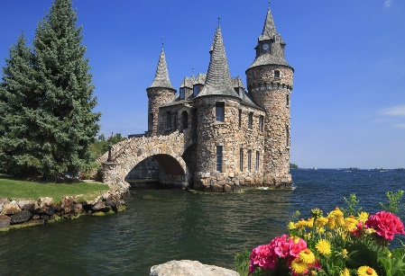 |  | Maths  - Practise writing numbers in words and numerals.  - Use a ruler or tape measure to measure things in your house. Measure at least 10 things and write the length in centimetres or meters. Order your chosen items from shortest to longest. Record in book. (e.g. Ruler- 30cm). Challenge compare them using < = > signs.  - Continue to practise telling the time to your grown-ups with the main focus on o’clock, half past, quarter past/to, to begin with.  - Find things around the house you can use to practise division as sharing and division of grouping. You could use raisins, grapes, lego bricks etc…  Link to video on division as grouping and sharing:  https://www.youtube.com/watch?v=bdglIPNNhuI  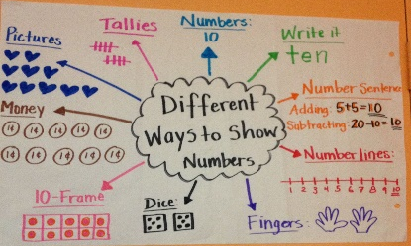  - Choose at least 5 numbers and show them in at least 2 different ways e.g. part part whole model, drawn at tens and ones etc. Challenge see how many different ways you can show the number 42.
Science  Watch BBC bitesize clip https://www.bbc.co.uk/bitesize/topics/zpxnyrd/articles/zxxsyrd on what plants need in order to grow.  Can you compare what plants need to grow and what humans need in order to grow. What are the similarities and differences. | Topic  Look at rooms inside a castle and design your own great hall and label the key features e.g. suit of armour and table.  P.E  If the weather permits, go outside and practise throwing and catching skills.  Join in with cosmic yoga on YouTube |  | Art/DT/Music  Banquet menu - Design a healthy  menu for a king or queen’s banquet. If you are able to, make one of the dishes you would serve.  Sing ‘The Grand Old Duke of York’. Accompany singing with  marching actions and musical  percussion to keep in time with the  beat of the music.
Our topic for this half-term is Tower, Tunnels and Turrets, some of the activities have been selected to introduce this. Websites you might find useful are on the Year 1/2 class page of the school website.

