English  - What invention do you think would change the world? Write the answer in your book.  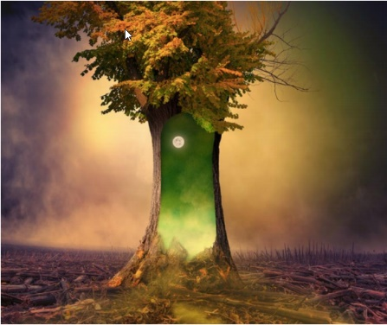  - Look at this photo. Answer these questions in your book (In full sentences).  - What do you think has caused the destruction all around the tree?  - Why has this one tree survived?  - If you walked through the portal, what would happen to you?  - If this portal went to another world, would you go? Why?  - Is it good to take risks? Are some risks riskier than others?  - Choose a book. Make a prediction and write what you think it will be about. After reading, extend the story by writing about what could happen next.  - Choose a book. After you have read it, pick your favourite character and draw them. Around your picture, write adjectives that describe what that person is like.  - Create an advert for one of your favourite toys. |  | Maths  - Go around the house and see how many things you can find that are in the shape of a sphere, cube, cuboid and cylinder.  - My answer is 22. I have used 3 numbers to make 22. What numbers could I have used? Write the possible combinations in your book. You could repeat with a different number.  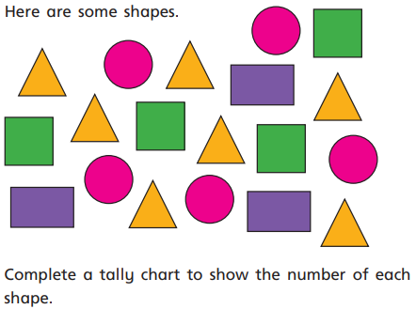  - Here are some shapes. Complete a tally chart to show the number of each shape.  - Practice your 2s, 3s, 5s and 10s timetables (or challenge yourself and learn one of the other timetables). Draw the arrays for 1 of the times tables in your book.  - In your books, partition these numbers (23, 54, 48, 82). Partition them into 10s and 1s first using a part-part whole model and then see if you can find different ways to partition them (e.g. 23- 20+3, 10+13).
Science  Find out the answer to these questions:  - What is a habitat?  - What are the names of some habitats?  - Name some animals that live in each habitat.  Challenge: Make your own habitat using things in your home. Take a photo or draw it in your book afterwards. | Topic  Find out about seaside habitats. Which animals live there? What do humans enjoy doing at the seaside?  P.E  Complete a kid’s workout from ‘The Body Coach’ (Jo Wicks) on YouTube.  R.E  Choose a task from Mrs Burton’s RE challenge. |  | Art/DT/Music  Use building blocks or Lego to build a sculpture.  Paint rocks and turn them into animals.  Research information about your favourite music artist and make a poster about them.

See previous planning or class page on the school website for links to useful websites.

