Friday 5th February 2021
Task: add an adverb to these sentences. Can you think of a different one for each sentence?
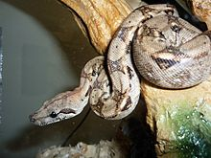 | The boa constrictor slid along  ___________.
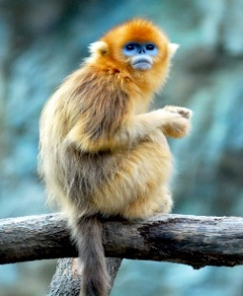 | The monkeys swung through the  trees ____________.
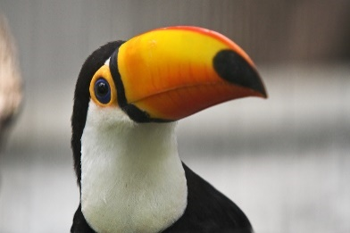 | The toucan squawked  _________________.
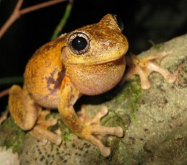 | Many small tree frogs jumped  ___________ in the pools.
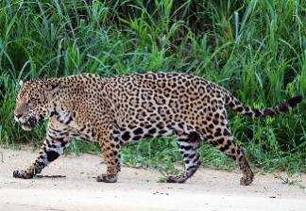 | Jaguars can creep very  __________ so that other animals do not hear them.
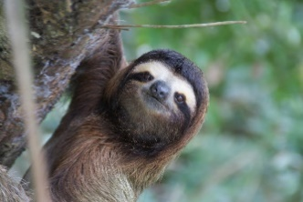 | Sloths like to sit  ___________in the branches.
Challenge – Write your own sentences, using an adverb, about animals of the rainforest.

