Monday 1st February 2021
Task 1: Match the animals to the descriptions. Draw in lines on a print out or move the descriptions next to the picture.
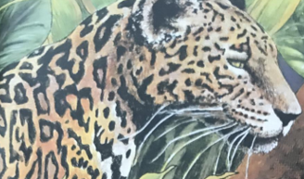
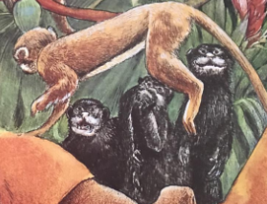
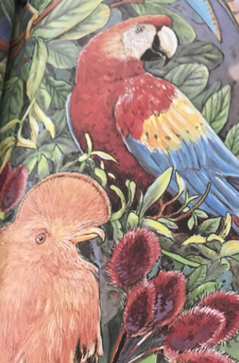
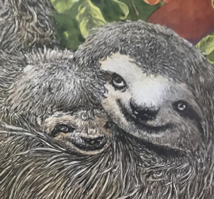
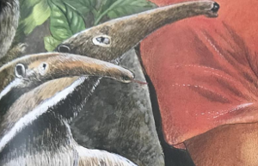
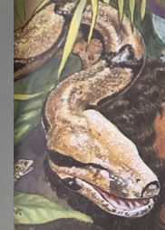
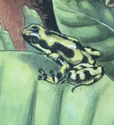
Who am I?
I have…
Task 2: Write your own description for a mystery animal.
Who am I?
I have a long, smooth, scaly body. My skin is brown with black stripes and I have sharp teeth in my mouth.
Who am I?
I have a small green body with black spots. I have no tail and big eyes to see predators. I have damp skin and love to swim.
Who am I?
I have a round face and sad looking eyes. I have stubby ears and greyish fur. I move very slowly and have claws on my feet to help me climb.
Who am I?
I have a long nose and tongue perfect for eating insects. I have brown fur and white stripes down my body. I have no teeth and a long bushy tail.

