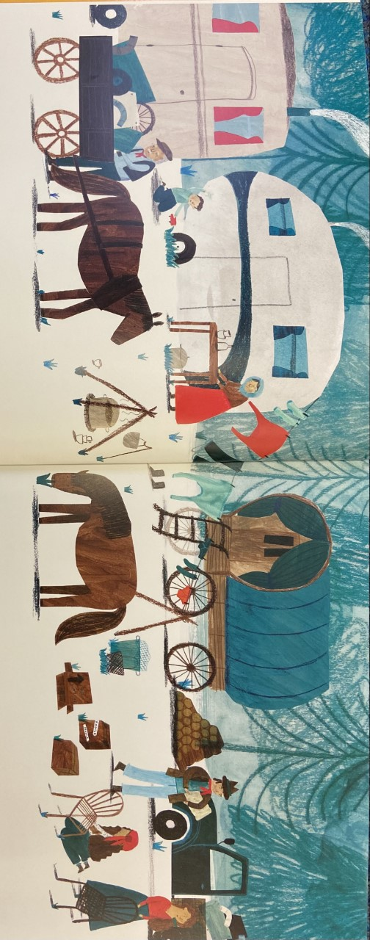
Friday 8th January 2021
LO: To describe a story setting
SC: To use adjectives
To punctuate sentences using full stops and capital letters.

Task: To write descriptive sentences to describe the above setting.

Example: In front of the tall green trees, there is a huge pile of brown wooden logs.

