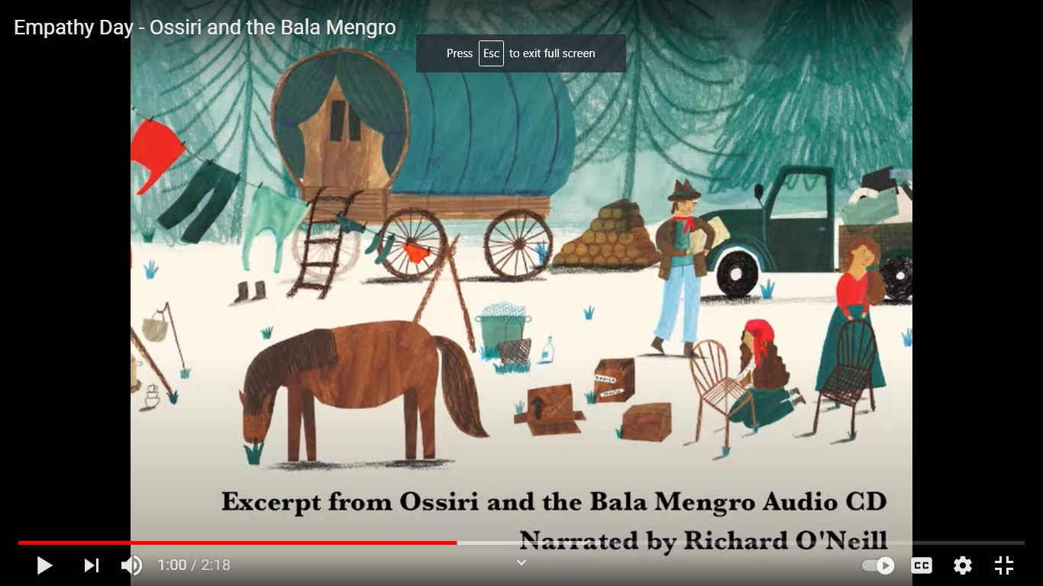
Wednesday 6th January 2021
LO: To make inferences based on illustrations
SC: To use full stops at the end of a sentence.
To use capital letters for names and at the beginning of a sentence.

Your task: To look at the picture of this character and write some sentences about who you think it is, what they are doing, what do you know about them.

Example: I think the girl is called Rose and that she broke her mums favourite chair because she was swinging on it. Now she is trying to fix it.

