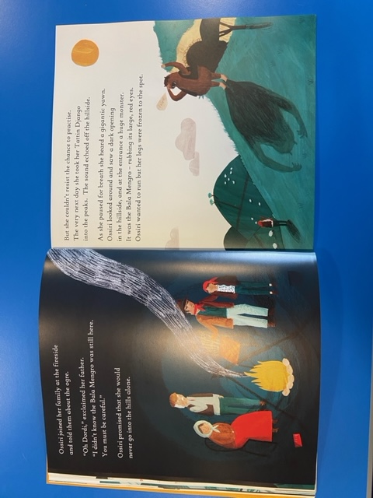
Thursday 14th January 2021
Ossiri and the Bala Mengro.
LO: To continue the story.
SC: To use adjectives
To use capital letters and full stops

Your task: To continue the story from the sentence… Ossiri wanted to run but her legs were frozen to the spot.

