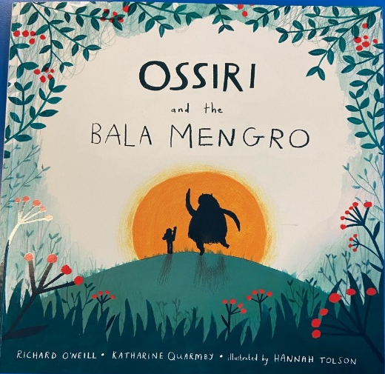
Wednesday 13th January 2021
LO: To identify and use adjectives.
Task: To think of different adjectives for those in the text describing the Bala Mengro and its environment.
Example: Ossiri is a small girl with long brown hair.
Ossiri is a little girl with beautiful long chestnut hair.

“A huge hairy monster, as tall as a barn. It lives in the cave up there.” The girl pointed up the steep hillside. “It loves its sleep and woe betide anyone who wakes it.”
As she paused for breath she heard a gigantic yawn. Ossiri looked around and saw a dark opening in the hillside, and at the entrance a huge monster.
It was the Bala Mengro – rubbing its large, red eyes.
Ossiri wanted to run but her legs were frozen to the spot.

