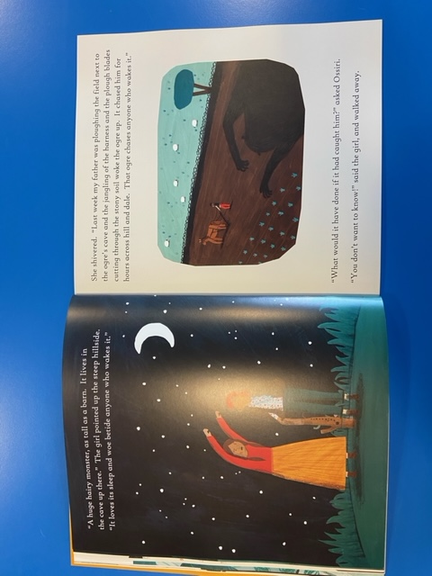
Tuesday 12th January 2021
LO: To imagine what a character is like based on the words used to describe them by the author.
Your task: Draw and label what you think the Bala Mengro looks like based on the description in the story.
Extension: use adjectives and similes to write your own description of the Bala Mengro.

