Half 14 =
Double 8 =
Half 8 =
Double 6 =

Count in 2s…
2, 4, ___, ___, ___, ___, ___, ___, ___, ___, ___, ___, ___, ___, ___

Count in 5s…
5, 10, ___, ___, ___, ___, ___, ___, ___, ___, ___, ___, ___, ___, ___

Count in 10s…
10, 20, ___, ___, ___, ___, ___, ___, ___, ___

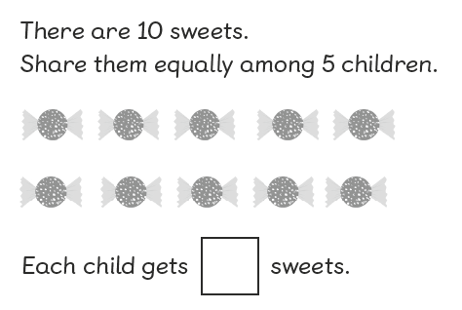
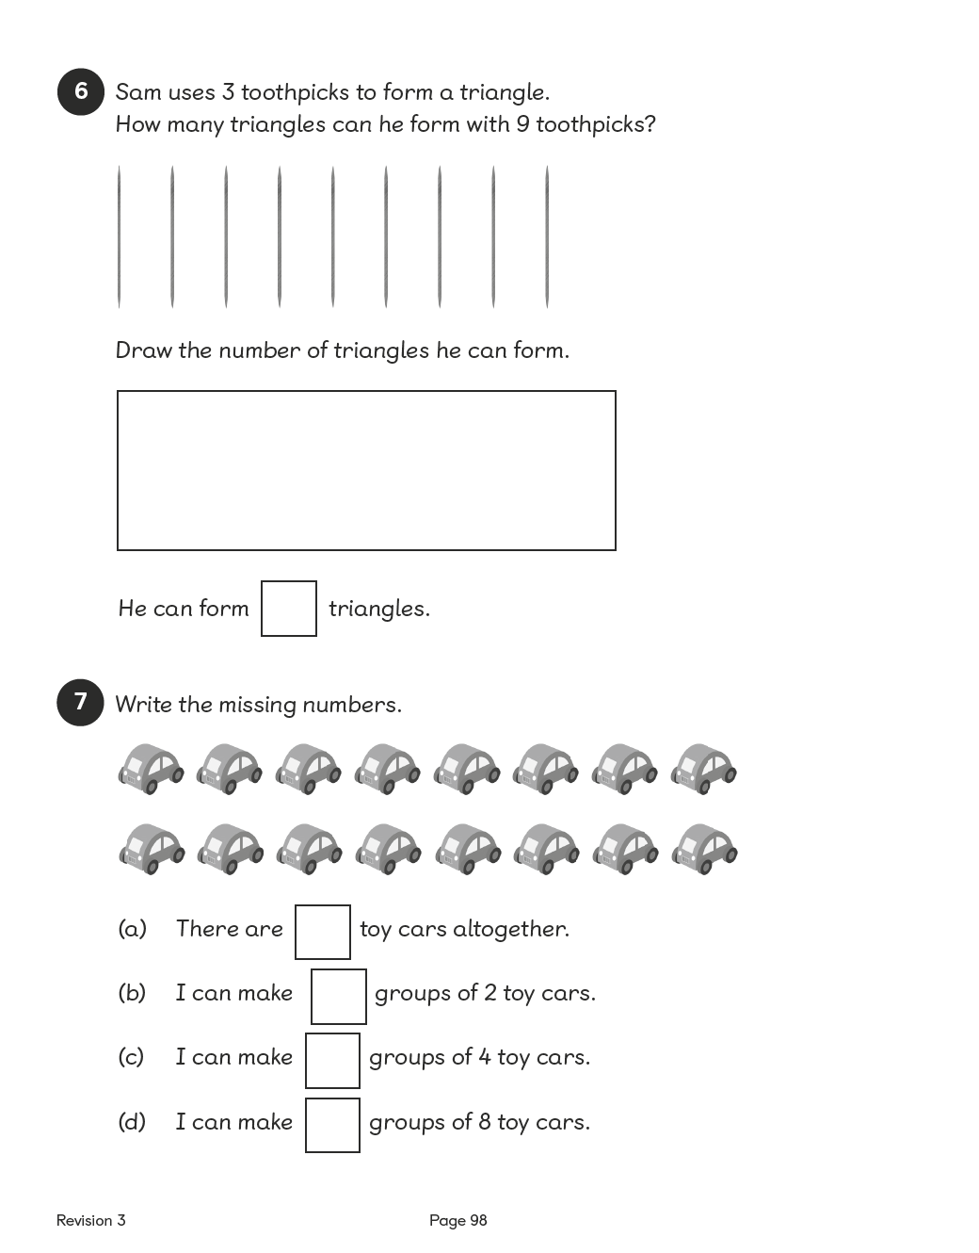

How else could the 20 sweets be shared out into bags equally?
Show me.

Sarah is filling party bags with sweets. She has 20 sweets altogether and decided to put 5 in every bag. How many bags can she fill?
Show me.

You can double any number, but you can only halve some numbers. Do you agree?

