Tuesday 4th May 2021 LO: To fill in the gaps in a diary entry based on pictures.

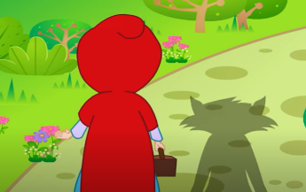
Dear Diary,
Today I went for a walk ……………………………………………………….
………………………………………. On my walk I saw ………………………
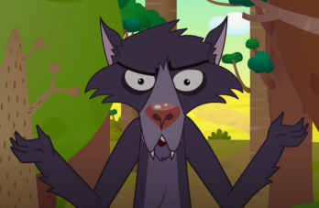
……………………………………………………………………………………………..
The girl told me she was going ……………………………………………..
……………………………………………………………………... because she ……………………………………………………………………………………………..
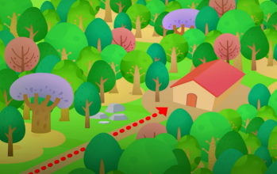
Then I had a great idea ……………………………………………………….
……………………………………………………………………………………………..
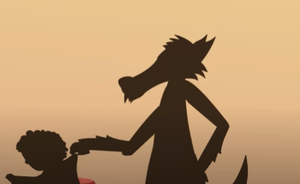
……………………………………………………………………………………………..
When I got to the house the old lady was ……………………………
………………………………….. Then I crept up and I …………………….
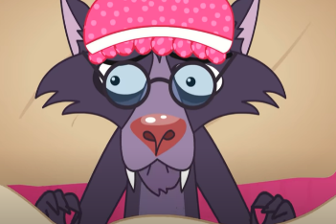
………………………. She was ……………………………………………………..
Next the little girl arrived and I was …………………………………..
……………………………………………………….. when she came close I …………………………………………………………………………………………….
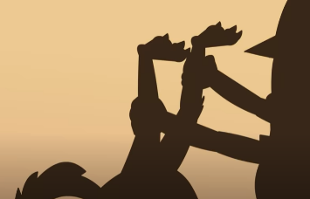
After I had just eaten the little girl a woodcutter came dunning into the and the …………………………………………………………………
…………………………………………………………………………………………….
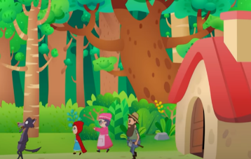
Finally, after the old lady and the little girl were set free ……..
…………………………………………………………………………………………………………………
…………………… Now I am ……………………………………………………………………….

