Task: Similar to yesterday, today the children need to write sentences/phrases using adjectives to describe the four characters.
Wednesday 25th November 2020
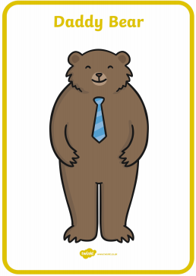
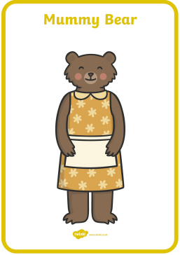
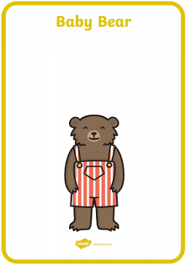
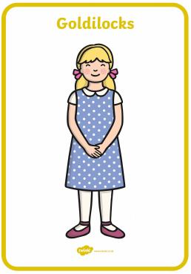
LO: Use adjectives to describe characters

