Task: Children to write sentences/ phrases using adjectives to describe the two main settings in Goldilocks.
Tuesday 24th November 2020
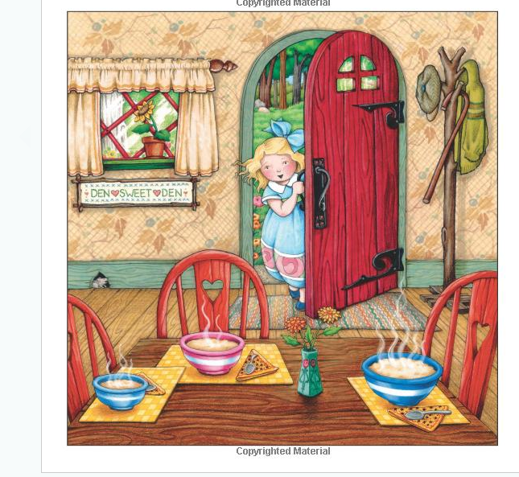
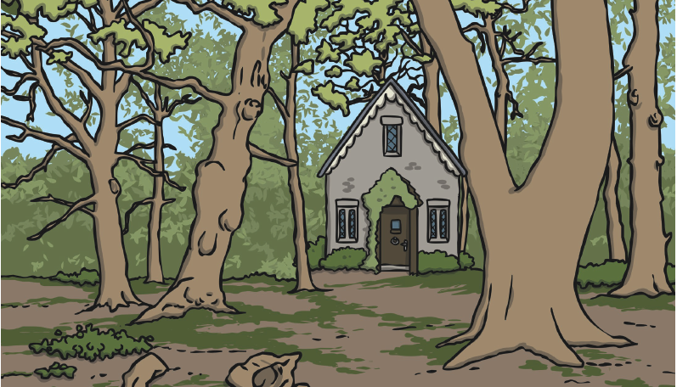
LO: To use adjectives to describe a setting

