Tuesday 11th May 2021 LO: To use speech bubbles

What sort of cake did you make?

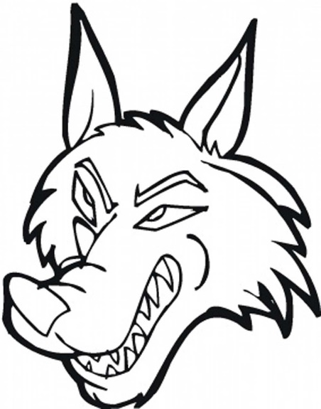
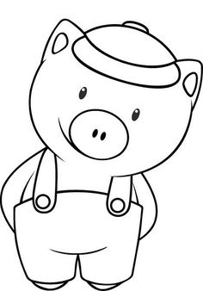

How did the pigs die?
How did you get the cold?

