Monday 12th July 2021
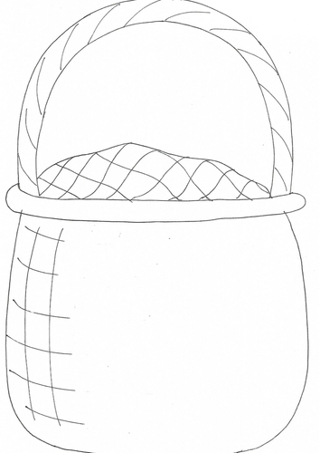
LO: Draw and label the items you think will be in Mr Grinling’s lunch

