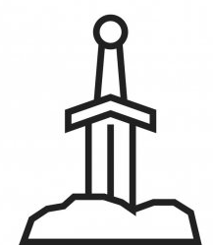
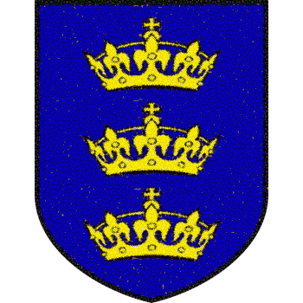
Whoever pulls this sword from the stone is the true-born King of England
A true king must;
- Be strong
- Be able to sword fight
- Have honour
- Have courage
- Be a man of the people
Come to The Abbey in London on Monday 7th March 1138 to find out
Are you strong enough to be the next King of England?

