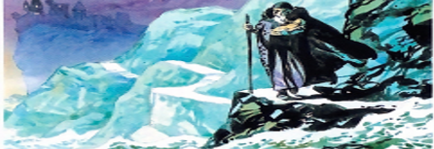
Your task is to describe it using powerful adjectives. Think about the things (nouns) you can see and write a sentence about each clearly. We are using the past tense, since we are describing what it was like at that time.
Use the wordbank available on the website.

