﻿Lemon and Blueberry Cupcakes

Ingredients (makes 12 cupcakes)
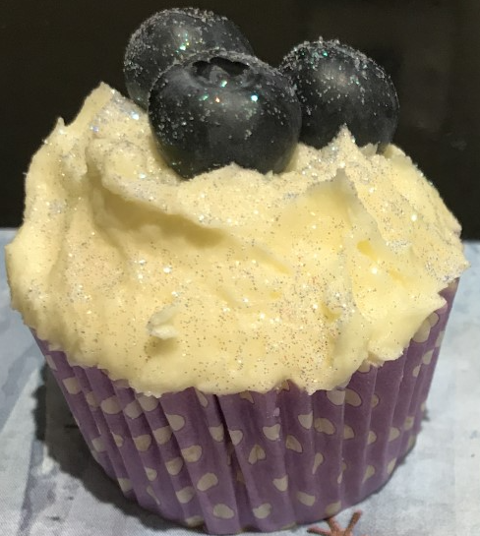
6oz self-raising flour
6oz caster sugar
6oz unsalted butter
3 large eggs
2tbsp lemon juice

Topping
8oz icing sugar
4oz unsalted butter
2tbsp lemon juice
Blueberries to decorate

Method
- Preheat the oven to 180 / gas mark 4
- Line a muffin tray with 12 paper cases.
- Mix the butter and caster sugar until a smooth consistency.
- Add the whisked eggs a little at a time to avoid curdling the mixture.
- Mix in the flour and add the lemon juice.
- Spoon the mixture evenly into the paper cases 2/3 full.
- Bake in the oven for 15-20 mins.
- And now the best bit, lick the bowl!

Tip - When you remove the cupcakes from the oven leave them in the muffin tray to cool a little, this will stop the paper cases becoming loose.

For the Topping

Mix the butter and icing sugar together and add the lemon juice.

Decorate with blueberries.
Add sprinkles, edible glitter or whatever you like as long as you are having fun and making lots of mess.

