Step by step, how to draw a parrot
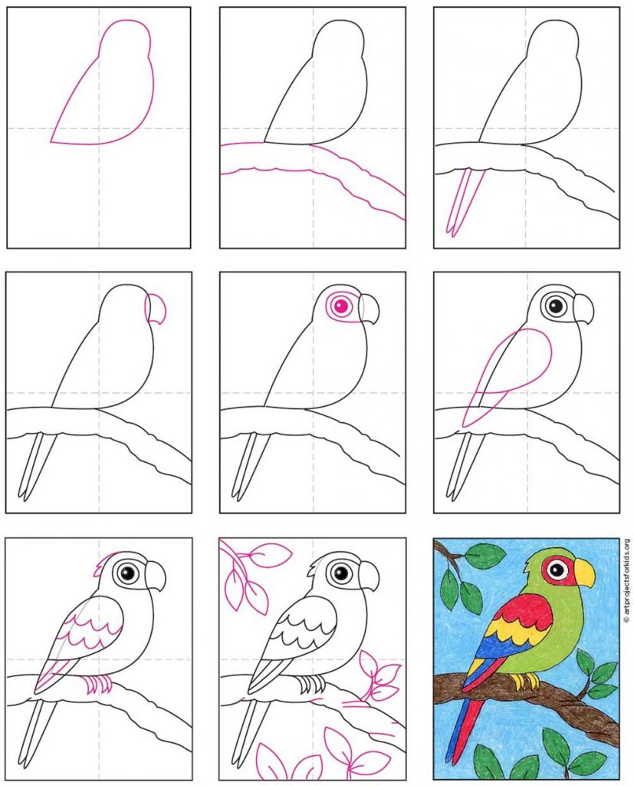
A4 paper- fold so you have 4 sections with a cross in the middle then follow guide below.

