Lesson | Monday |  |  | Tuesday |  | Wednesday |  | Thursday |  | Friday
Phonics | RWI Set 2 Sounds  Revisit all the sounds. Can you record them on a piece of paper? |  |  | RWI Set 2 Sounds  Focus on /air/  Complete rhyming thread on paper.  Hair, chair, fair  Apply in a sentence using red words.  E.g. She has fair hair. |  | RWI Set 2 Sounds  Focus /ir/  Complete rhyming threads:  Bird, twirl, skirt, girl, birthday.  Apply in a sentence with red words.  E.g. They are at a birthday party. |  | RWI Set 2 Sounds  Focus: /ou/  Record rhyming threads:  Shout, about, round, mouth  Apply in a sentence with red words.  E.g. Some shapes are round. |  | Jedi Handwriting  Pencil and paper at the ready!
Literacy | Yucky Worms  Introduce the book ‘Yucky Worms’. Focus on the front cover. Who is this the boy? What is he looking at? Why are the worms underground?  Write a sentence about what the boy is going to do. “He is looking for worms”. |  |  | Yucky Worms  Show the first double page, without the words on. Discuss it. Who is the boy…the woman? Where do you think they are? What are they doing there? Why is he pulling that face? Can you pull that face? What is she holding in her hand?  Talk about speech bubbles. Discuss what the boy or the gran might be saying.  Write a sentence about what the boy/ Gran might be saying to one another. “Look at the worms” or “You have worms in your hand” |  | Yucky Worms  Read the first page. Pose the question: Are worms yucky or not yucky?  Discuss how the children feel, asking them to justify their responses. they might begin to use words to describe the feel or the movement of worms which can be expanded upon. They might know something of the benefits of worms and their role.  Write a sentence stating whether they like worms or not and why (using because) “I like worms because they feel slimy”. |  | Yucky Worms  Tell the children the book is an information book, it’s going to tell us a lot about worms. Before they read the rest of the story, ask them to talk about what they would like to find out about worms. Discuss.  Write a sentence asking what they would like to find out about worms. “Why do worms like the mud?” |  | Yucky Worms  Read the whole book.  Show the children the letter that has been delivered for the class. Open it and read it aloud. Discuss.  What do they think of information books?
Book:

Yucky Worms
Remember to always use:
*cursive letters ~ except for when a capital letter is need
*finger spaces
*full stops
* a pencil

Children should use their phonics to phonetically attempt words however if it is a tricky word or frequently used word e.g. he, was, one, then we would be encouraging them to learn the spellings and apply them to their written work
Maths  Link |  | Two of Everything | Double The Ducks |  | Doggie Double |  | Double Trouble |  | Join in with the song:  Doggie Double
Task: |  | Find A mirror and play with making two or ‘double’ of everything.  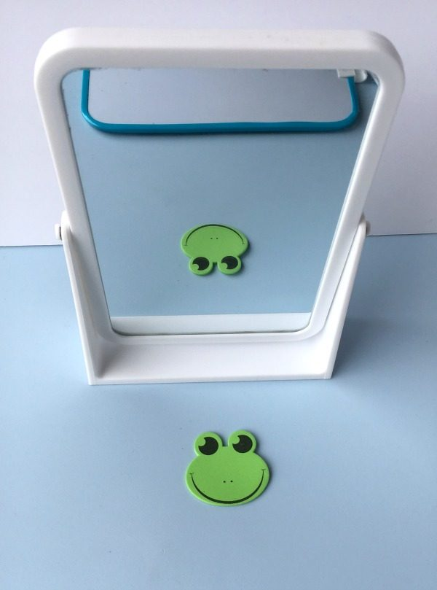 | Pause at front cover- what do you notice about the freckles on the boy’s face. He has 3 on one side and twice as many on the other side. Double 3  Pause on each page to explore the doubling. Ask chn to practise using their fingers. |  | Finger maths: Use fingers to double. Go through examples 0-5.  Then move on to-  So I know that double to is 4…  Invite chn to demonstrate to the class.  Make some deliberate errors (1 finger up on hand side 2 fingers up on the other). Is this double? Why? Why not? |  | Can you double like the Numberblocks?  Use cubes, counters or pasta etc to make doubles. |  | Can you make some Ladybird doubles? Draw the ladybirds and double the spots.  

