Lesson | Monday | Tuesday | Wednesday | Thursday | Friday
Phonics: | Recall all digraphs  Set 1 and focus set 2 sounds | RWI: /OW/  Blow the snow!  Red word : was | RWI: /OO/  Poo at the Zoo!  Red word: go | RWI : /OO/  Look at a book!  Remember we join up our digraphs at Bishopton!  Red word: some | Handwriting  Work through the video to practise writing each letter sound.
Phonics  Task | Play ‘roll and write’. Orange board only. Practise reading and writing red and focus digraph words. | Work through the videos to recognise the new digraph sounds. Read the green words with an adult and have some paper or a white board at hand to record the focus sound words given on the videos.  Remember your ‘Fred Talk’ Reception- Clear segmenting and blending.  Alphablocks additional links: ow snow, oo moon, oo book |  |  | Can you write a sentence using each of this week’s red words?  Was/ go and some? Remember to start and finish your letters in the correct places.
For this week’s maths, we are using the Teaching videos from White Rose Maths – Growing 6, 7, 8
Please use the hyperlinks to access the videos and worksheets
Daily practise – saying and writing numbers to 20, counting objects, Numbots
video | Session 1 video – matching 6, 7, 8 | Odd and even numbers  Numberblocks | Doubles  Numberblocks | Hit the button game | Maths investigation
Maths  Task | Pairs game  You are going to make your own pairs game up.  Either make your own cards up or use the template  - Draw a different story of 8 on each card – make sure you use a different pattern!  - Now can you say or write an addition number sentence for each domino?  - Now a challenge – can you write down a subtraction number sentence?  - Now play the pairs game with your grown up.  ENJOY! | Socks galore!  Ask your grown up for the bag of socks  What do you notice about them?  Can you count how many socks there are? Write it down.  Is that an even number or an odd number?  Let’s find out.  Put the socks in pairs. Are there any left over? If there are, it’s an odd number.  Now try with a different number of socks.  Sock worksheet  Fancy a challenge?  Try this | Double trouble game  You need:  - Up to 20 objects e.g. pasta  - 2 plates  - A bag  Put all the objects in the bag.  Player 1 – takes a handful from the bag and drops it on the plate  Player 2 – counts the objects and then tries to work out the double  e.g. 2 – I think double 2 it 5  Now using the objects, player 2 checks is they are correct by placing the same amount of objects on the empty plate.  First player to score 10 wins!  Ladybird doubles  Ladybird challenge | Choose ‘Number bonds’ and have a go at the activities in ‘Up to 10’ or why not challenge yourself by choosing another option!  Using the worksheet – can you write a number sentence for each domino?  3 + 5 = 8  Extension  Can you complete the race track using the dominoes?  If you haven’t got a printer, draw out your own dominoes. | Bob the explorer is counting creatures in the rainforest – he is looking for spiders, butterflies, dart frogs and humming birds.  He can only see the creatures’ legs and has spotted 10 legs.  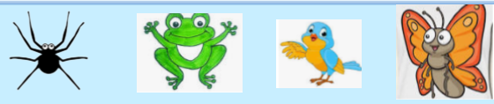  Bob has worked out:  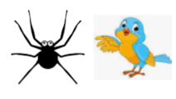  8 + 2 = 10  What other combinations can you find?  Animal printout
Guided reading  BUG CLUB | A Big Mess | Big, Fat Rat | Big, Fat Rat | Doll is Ill | Doll is Ill
Story  CLL | All resources are now on the class webpage under the ‘Remote Learning’ icon.
CLL activities | Let's Celebrate- Chinese New Year  What have you learnt about the celebration of Chinese New Year?  Talk to your adult trying to use full sentences to explain your ideas.  Have a go at writing the Chinese numbers 1-10.  They are on the website for you to copy. |  | My First Chinese New Year- Story  Can you use your phonics to write 3 sentences about CNY? How is Chinese New celebrated?  Use paper or there is Chinese themed paper on the website. |  |  | The Great Race- Story  Choose and animal from the story. (There are colouring pages to print off if required.)  What do you like about this animal? Can you write a caption or sentence? |  |  | Cbeebies: Zodiac story  Find out which Chinese year you were born in. Can you draw a picture of your zodiac animal and write a sentence?  E.g. I was born in the year of the rat. |  | Watch ‘Go Jetters’ and enjoy learning about The Dragon Dance.  Dragon dance  What do the dancing dragon’s look like? Do you like them? Can you think of some adjectives to use in a sentence?  E.g. They are bright, red and gold.
This week we are looking at Chinese New Year. – all instructions are on the website.click on the hyperlink
Afternoon  activities | Make dragon cookies  Click here for the recipe | Make a Chinese drum  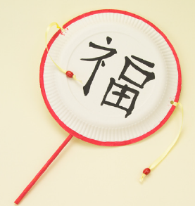 |  |  | Make a Chinese dragon  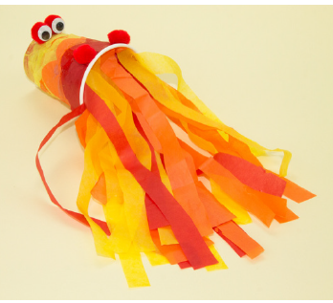 |  |  | Blossom tree painting  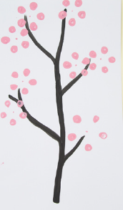 |  | Make a dragon costume  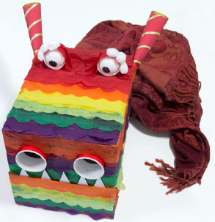
PE links | Getting ready for the New Year  Chinese New Year Parade  Cracker the wonder dragon yoga |  |  | Creative –  Music and Movement |  |  | CNY Song and music  Can you dress or make something red to dance along to the music? Could you make an instrument to play along with ?  Ideas for making musical instruments  Some rice in an empty bottle is also fun to shake and dance with.

