Lesson | Monday | Tuesday | Wednesday | Thursday | Friday
Phonics: | Phonics Revision set 1/ red words | Set 2 revision- Alphablocks | oo/oo song | Set 2 Green words activity  Some of these sounds will be new digraphs but we will be learning them soon. | Back by very popular demand!  Jedi Handwriting
Phonics  Task | Early Comprehension PP.  Use your phonic knowledge to read through and answer the questions. There are some red words too!  Please note: /oi/ ai will be unfamiliar sounds. | Read and colour the ‘Real and Nonsense’ /igh/ words. | Long and short /oo/ read and roll game.  Challenge: Can you write some sentences with these words in them? | Work through the video pausing with each new word. Can the children read the green word? | Practise writing and saying the sounds.  Can you practise your handwriting of these red words:  are/ was/ all/ the/ you/ said/ he/ she/be/ we
For this week’s maths, we are listening to stories and investigating length and height
Daily practise – saying and writing numbers to 20, counting objects, Numbots
Stories | Titch | Short or tall – it doesn’t matter | Where is my Teddy | I want to be tall | The tiny seed
Maths  Task | Shoe prints  Look at each other’s feet – who has the smallest, who has the biggest?  Now draw round and cut out your footprint.  Put the foot prints in order of size.  Now grabs some cubes / coins / pasta tubes  Predict how long each foot print is in cubes / coins / pasta tubes.  Now test – who was closest?  You will need your footprint for the rest of the week | How big?  Using your footprints from Monday – measure the objects around your house, using your footprint as a measure.  First predict, then test  How long is  - the TV  - your bed  - the sink  etc  in footprints?  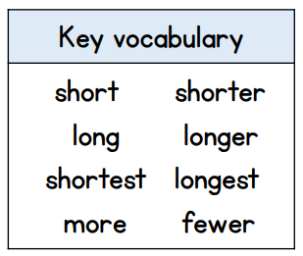 | Comparing length  You need to hunt around the house and find 10 things that are:  - longer than your footprint  - shorter than your footprint  - the SAME size as your footprint  Can you record this on paper? | Body height  Who is the tallest / shortest?  Predict how tall each person in your house is, using your footprint as a measure.  e.g. I think Mummy is 40 footprints tall – write it down,  Now get them to lay down and you measure how tall they are in footprints.  Were you correct? Who was the closest?  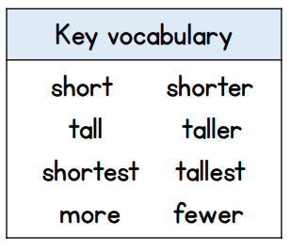 | Investigating body length and width  You will need:  Chalk / felt tip, large paper or use outside.  Lie on the floor / paper with your legs straight and your arms out wide  Get Mum/ Dad to draw round you.  Investigate and prove:  - Your height is the same as 10 of your footprints  - Your height is the same as the length as your arm span.  What have you found out / proved?  Is it the same for Mummy, Daddy, brother or sister?
Guided reading  BUG CLUB | Pink B  Alphablocks: Get a Pet | As Yesterday | Alphablocks: Huff! Puff! | As Yesterday | Alphablocks: Is it a Rock?
Story  CLL | Jack and the Beanstalk  Jack and the Beanstalk
CLL activities | Share the story (follow the link above)  Jack and the Beanstalk- cutting skills activity.  Create your own story beanstalk and talk about what happens in the story. Can you label the pictures?  E.g. Jack, hen, mum etc |  | Jack and the Beanstalk- Nick Sharrat version  How was this version of the story the same or different? Do you like the story? What do you like? How would you change any part of the story? Would you like Jack to find something else in the Giant’s castle? Could you write a sentence? |  |  | Complete the cut and stick story map.  Can to retell the story using words like:  One day  Then  Next  After that  At the end of the story |  | Watch this fun version from the story:  Alternative musical story adventure- JAB  Try to write so sentences and captions from the story.  - JAB writing activity or alternatively draw a picture from the story and write a sentence to describe what’s happening. |  |  | Here is our character for the day- The Giant  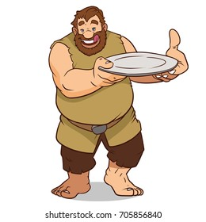  Please find the file : The Giant and use the questions as an activity for creative writing today.
Afternoon  activities |  | Seed hunt  You will need:  - Tomato  - Cucumber  - Apple  Chop the fruit in half and look at the seeds –  What colour are they?  How big?  What do they feel like?  Can you find anymore seeds in fruit? |  |  | Grow your own tomatoes plants.  Use the tomato half from Wednesdays math’s task  Fill a pot half full of compost / soil  Lay the tomato half in the pot .  Cover with compost / soil.  Water the pot  Cover the pot the pot in cling film and leave in a warm sunny spot |  | Life Cycle of a bean  Watch the video  Now order the pictures and match the captions.  Why not try and grow your own bean! |  |  | Build a beanstalk  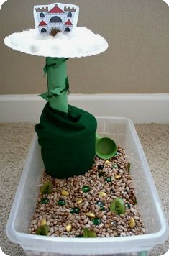
PE links | Jack and the Beanstalk Moves  Can you extend these moves? How many times can you lunge across the giant’s castle?  Jack and the Beanstalk Yoga session |  |  | Make sure you keep checking on it to see if it needs more water!  Why not try growing sunflowers too! |  |  |  |  | Creative- Music: Jack and the Beanstalk  JAB- Various songs and music activities  Sing along or take your instruments out and play them to the rhythm of the songs!

