Lesson | Monday | Tuesday | Wednesday
Phonics: | oo/oo song | ar sound | Alphablocks recap and revise
Phonics  Task | Play 3 in a row with two colours for oo/oo.  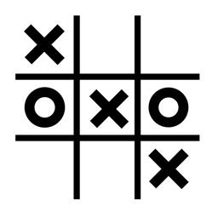 | Create a list of /ar/ rhyming words. | Use your letter formation sheet to practise orientating the letter sounds.
We are continuing with our investigations – Fancy playing a game? Try
‘Hit the Button’ ‘Robot Addition’ or ‘Higher or Lower’

Maths  Task | Beanbag buckets  It is time to dig out your buckets!  Now number them 1 to 4.  Using three bean bags/balls – what is the highest score you can get?  See game for more challenges!  Game  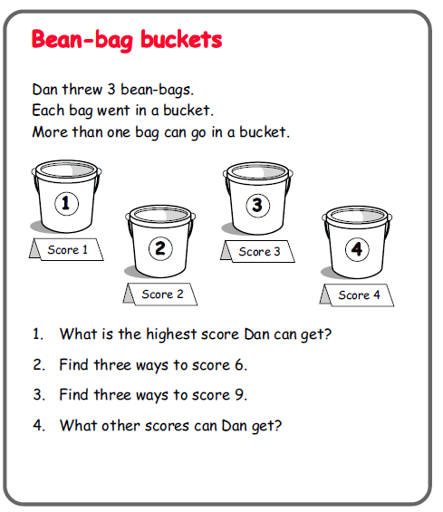 | Card sharp  Ever fancied being a magician? Can you find 3 cards that total 12?  To help, use these number cards  Game  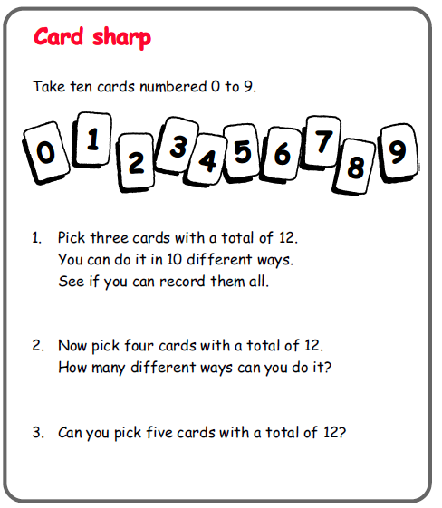 | Sum up!  Fancy a challenge?  Can you find 3 numbers that add up to 12.  To help, use these number cards from yesterday.  Game  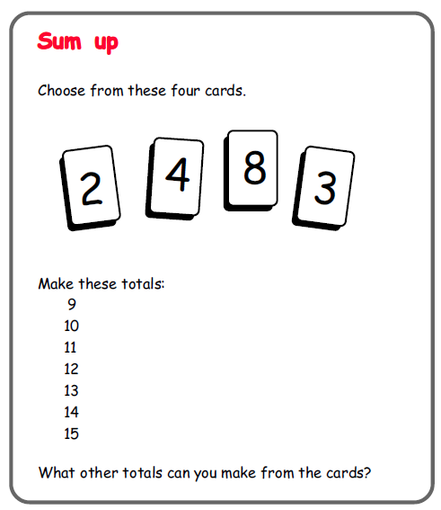
Story  CLL | The Egg  The EGG  Read the book again. - focus on finding all the describing words in the book.  Focus on the scene where George meets the dragon’s family. Has our dragon got a family somewhere?  Writing task-  What kind of home does the dragon have with his family? Draw and label/ write a describing sentence. | Imagine the dragon meets our class dragon.  What adventures could they have?  Draw a picture and write a sentence. | Share the story for a final time.  What is your favourite part? Are there any parts of the story you don’t like? Why?  I don’t like it when the dragon goes away because I think George will be lonely.  What do you think the dragon would say to George?  Complete the dragon speech bubble.

