Lesson | Monday  For Parents: What is a digraph? Useful information video for parents | Tuesday | Wednesday | Thursday | Friday
Phonics: | New red word: are  New sound /sh/  Sh sound | Look at the letter formation flashcards in the ‘files’ section on teams. Practise writing some of the letters. | New red word: he  New sound /th/  th sound | Recall all sounds set 1.  RWI set 1 sounds review | New red word: she  New sound /ch/  ch sound
Phonics  Task | Record some /sh/ words as modelled in the video.  e.g. ship/ wish/ shop/ dish | Practise writing all the red words using correct letter orientation:  the/ my/ you/ said/ to/ into/ are | Can you practise writing the digraph /th/?  Can adults write a few /th/ words for you to read? Could you write any? | Share the video and try and write a caption.  E.g. this is my bed.  Use your phonics to sound out the words. | Can you draw and label some items which have the /ch/ sound?  E.g. Cheese/ chips/ chimp/  Can you think of any other words that have the /ch/ sound?
For this week’s maths, we are using Teaching videos from the Oak Academy. Each video has an activity linked to the task. Please click on the hyperlink below to start the video.
Online video links | Using and understanding the words heavy / light and heaviest / lightest | Comparing weights of objects | Recognising the difference between heavier and lighter |  | Recap of learning
Maths  Task | Bake a cake  Using the recipe, bake a cake.  Click this link website for the recipe  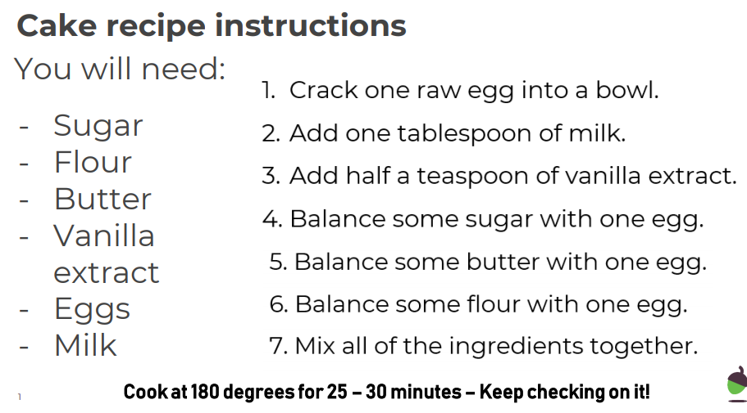  Or why not, try making your own cakes | Ordering objects  You will need:  - Up to 10 objects  - Kitchen scales  - Heaviest / lightest ordering labels  Your task is to, using your hands as a weighing scale, order your objects from lightest to heavier.  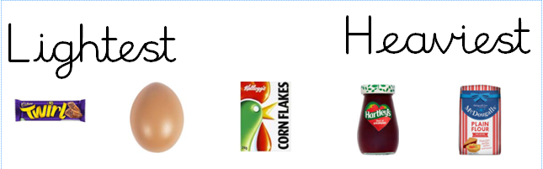  Now check using the scales – ask your grown up to write down the weights.  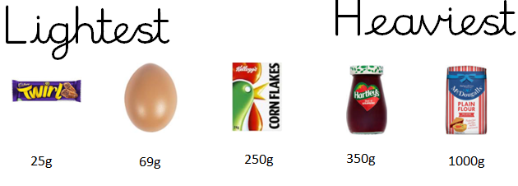 | Activity linked to video  You need:  - Up to 10 objects  - Kitchen scales  - Heavier / lighter labels  Using two items at a time – use hand to compare the weight of the objects. Decide which is heavier and create a sentence using the signs.  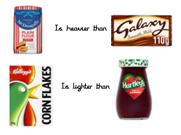  Now check using the scales. | Seesaw Shenanigan  A group of animals have met in the wood and are trying to find out who is the heaviest – Can you help?  Click on this link  Which animal is the heaviest / lightest?  Can you order them?  Use this worksheet to investigate more  Or draw your own! | Investigation  Can larger items weigh less than smaller items?  Go round the house collecting different sized objects and using the scale – check if this statement can be true?  e.g. Can a jar of jam be heavier than a box of cereals?  Draw pictures of what you have discovered!
Guided reading  BUG CLUB | Tim’s Din | Tim’s Din | Cookies | Cookies | Sarah and Duck:  Duck and the Balloon
Story  CLL | The Snowman  Jack Frost
Activities | The Snowman flying scene  Use the prepared picture ‘The Snowman’ from ‘files’.  Record what is happening in the picture. | Use phonics to record a caption for the second picture from files.  E.g. The boy gave the snowman a hug. |  | The Snowman and the Snowdog Clip  Share the clip. Discuss what’s happened. Has the snowman got a snow friend?  Draw a picture of a snow friend you would make for the snowman. Can you label your picture? |  | Introduce: @’they’ for writing.  Use yesterdays snow friend character.  Can you write an adventure that the Snowman and your snow friend had?  E.g. They went to the park. They had a pizza | Jack Frost  Share the story. Where do you think Jack Frost went and why?  Jack Frost meets The Snowman. What happens next?
PE links | Cosmic yoga – Joybob the Polar Bear  Snowy days dance  Pedro the Penguin |  | Creative activities |  | Snowman biscuits  Snowman Marshmallows  Snowman String balls | Make a Penguin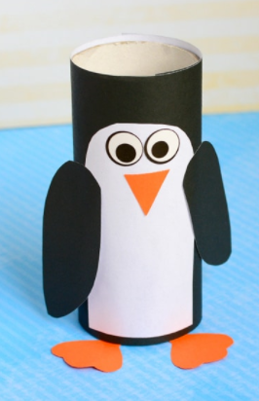Winter play dough ideas  No cook play dough recipe

