Lesson | Monday | Tuesday | Wednesday | Thursday | Friday
Phonics: | Information for parents on how to support your child to blend for reading and spelling.  Information video for parents. Early reading and spelling. (This will be useful for supporting our daily phonics tasks)  Share the letter sound cards previously sent home from school or sent via email last week.  Can the children practise saying the sounds on the letter cards? | CVC words  Watch the video together. Can you read the words? | Reading CVC words PP1 (located in the ‘files’ section in our class Teams) | The tricky word rap! | Jedi writing
Phonics  Task | See image in ‘File’ section on Teams. Phonics stairs photo. Use the letter cards (or post it notes) on the stairs or around the room. Practise saying the sounds or making words with the letter cards. | Try to use the sounds to write some words with red word /the/.  E.g. the pen, the dog, the van. | Read and then write the words together. Can you put some of the words into a sentence? | Watch the video of the tricky (red) words rap.  Can they read the words and join in with the song?  Would they like to try and write some of the words? | Practise writing some letters. You may wish to watch the videos through once and then pause and practise each one! Don’t forget to say the sound each time and start in the correct place.
Maths | Please access the videos for each day here Alive in 5 week 1
Outcomes | Explore number bonds to five | Understanding the concept of 0 | Number bonds to 5 | To recognise more / less and work out difference |  | Equal and unequal sharing
Maths  Task | Session 1 video  Draw a 5s frame    Collect 2 different coloured counters / objects  Find different ways of making 5 by filling up your frame.  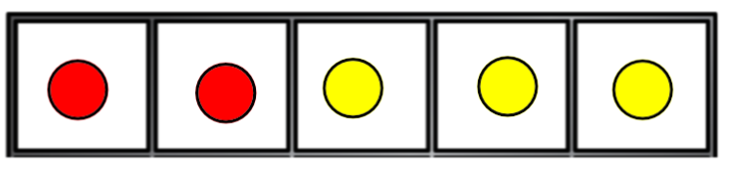  Can you write a number sentence to match  e.g. 2 + 3 = 5 | Number Blocks  Toys on the bus  You need:  a cardboard box, 10 toys, number cards to 5  Now make your box into a bus.  How to play:  - Shuffle the cards  - Pick 2 card add the numbers up and put that many toys in the bus  - Now pick another card and take that many toys out  How many toys do you still need to take out to make 0 | Session 3 videos  Follow the White Rose activity  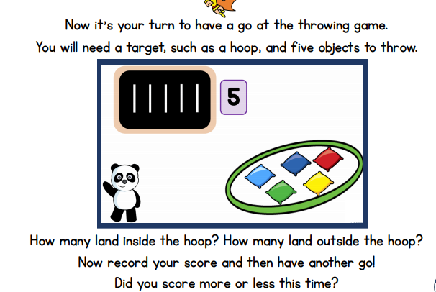  Why don’t you now use 2 or 3 hoops and more objects.  Can you write out a number sentence for each? | Session 4 videos  Grab two plate, a bag of pasta or a handful of cubes / counters.  Grab two handfuls of pasta and drop them on each plate –  Predict which plate has more?  Now count – were you correct?  Can you work out how many more? | Session 5 videos  Follow the White Rose activity  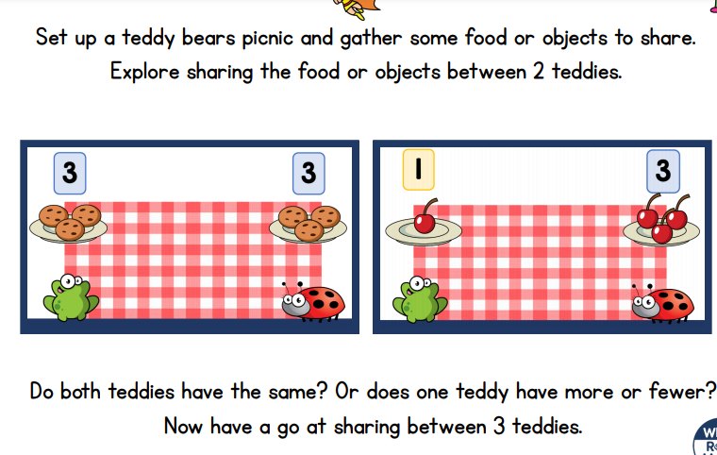  Or why don’t you plan a picnic with your family?  Set the table with knives, forks, plates etc – how many do you need?  Now share out the food.
Guided reading  BUG CLUB | Pink level:  Sid, Did it! | Repeat Monday’s book | Sid’s Nits | Repeat | Sid’s Pit
Story  CLL | This week we are exploring the wonderful story of ‘The Snowman’ by Raymond Briggs. The story offers rich language opportunities to verbally sequence stories and characters. (The children don’t actually watch the story until Tuesday!) Please use the ‘files’ section on the Teams account to access resources.  Optional tasks (Please see the ‘files’ section on our class Teams account)  The Snowman colouring sheets  Snowman cutting skills activity
Activities | File: Monday 11.1.21- The Snowman image  Share the image and discuss what the children can see using the questions as a prompt for discussion.  Either: Draw and describe their own snowman picture or use the ‘Design a Snowman’ in the files section. | The Snowman  Watch and enjoy the story of ‘The Snowman’.  Discuss their favourite parts of the story. Did they guess what would happen at the end? | The Snowman  Use the video for support to act out parts of the story. You could either dress up as the characters or use the story stick puppets available in the files section.  What might the characters say?  Can you use your phonics to write some of the words from the story? | Discuss where you would like to fly with the snowman.  What would you like to see?  Can you draw or write about what you see.  E.g. I can see the North Pole.  I can see a big sea. | Can you talk about different parts of the story?  Key words: Beginning, middle and end.  Can you draw a picture from each part and discuss/ record what’s happening? Alternatively, the story sequencing pictures are available in the files section.

