Lesson | Monday | Tuesday | Wednesday | Thursday | Friday
Phonics: | Red word reading | /ar/  Start the car  Red word : her  /ar/ Alphablocks | /or/  Shut the door  Red word: call  Additional: /or/ Alphablocks | /air/  That’s not fair  Red word: want  Additional: /air/ Alphablocks | Jedi Handwriting  It’s Friday so lets practise writing our letters! White boards at the ready!
Phonics  Task | Practise saying these red words within a sentence. Can you try and write one of the sentences? | Watch the video and learn this new digraph.  Write a list of rhyming words which have the sound /ar/. | Work through the video reading the green words and writing the /or/ words given. | Learn about the trigraph /air/. White boards at the ready!  Read the green words and write down the words with the sound /air/.  Real and nonsense words /air/
Online videos | Session 1 video | Session 2 video | Session 3 video | Session 4 video | Session 5 video
Maths  Task | Can you match it?  Using the worksheet - can you count the objects and match it to the numeral?  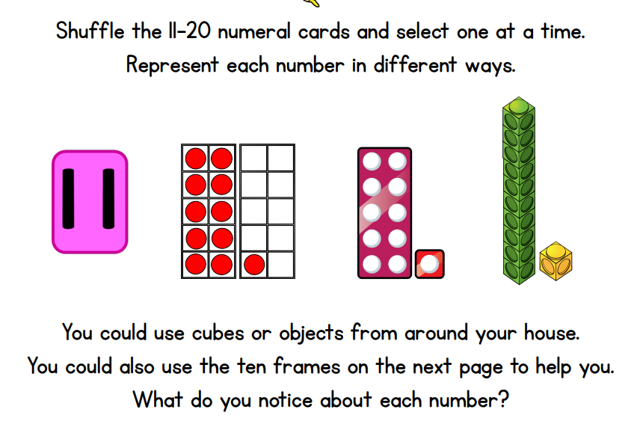  Why not go on a treasure hunt around the house and make up patterns with 20 objects? | Pairs game  Using the worksheet, play the memory game, matching up the numbers to 20 with the correct picture card.  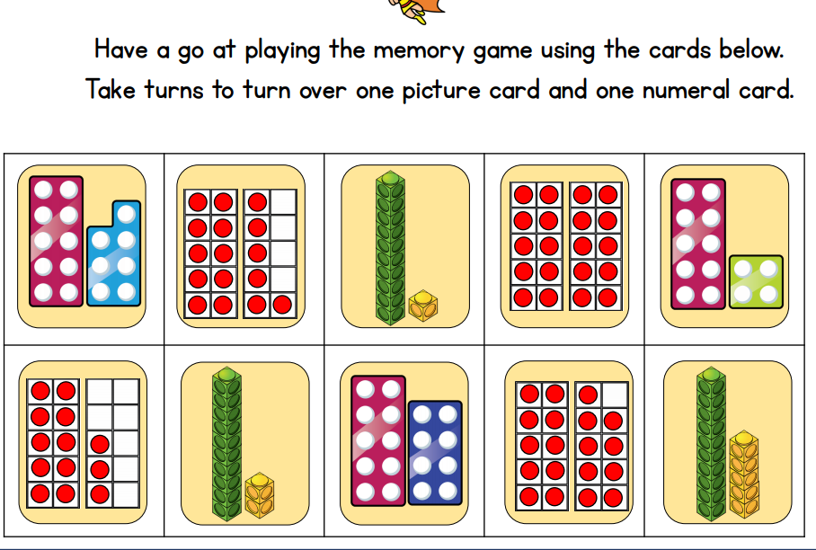  The winner is the one who has the most pairs! | Race to 20  You need:  - Worksheet or draw own tens frame  - Numbers cards 1-10  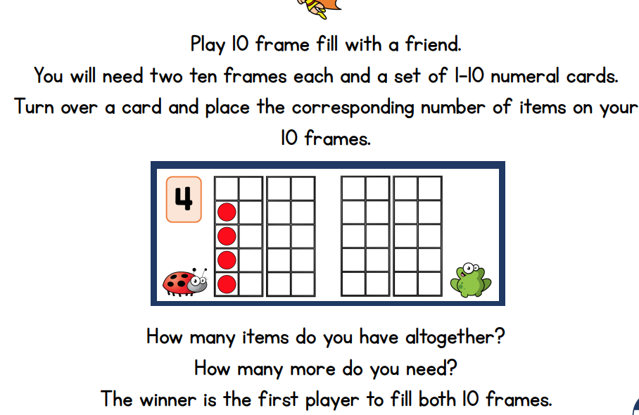  How to play:  - Shuffle the number cards  - Turn one over and place the number of items of your frame  - Take it in turns  The winner is the first one to 20!  Good luck! | Can you guess how much?  You need:  - A bag of small objects  - 2 / 3 plates  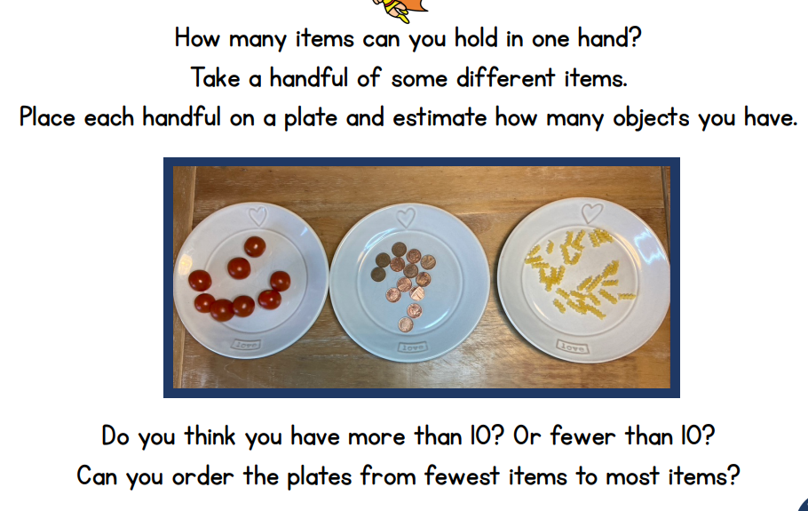  Grab a handful of objects  Drop them on a plate  WITHOUT counting, estimate how many objects you have  Now count  Were you correct?  Worksheet | Ten’s frame subtraction  You need:  - 20 counters each  - A dice  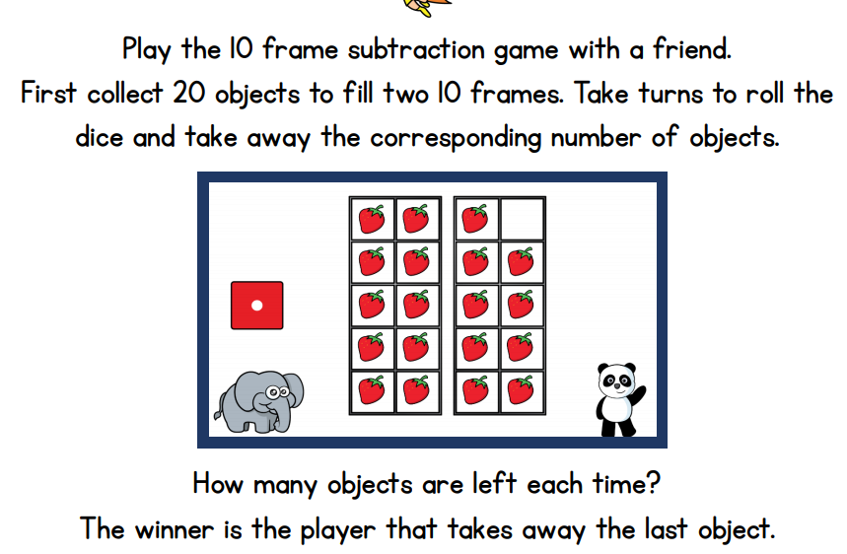  Put all the counters on the grid  Take it in turns to roll the dice – each time take the right num,bers of counters away.  The winner is the first one to empty their frame!  Worksheet
Story  English | The Queen and her Grandchildren  Watch the video and talk about their relationship with a special family member. What do they like to do?  Sentence writing: E.g. Granny plays ball with me. | Share the story: Be Kind  Be Kind  What does kindness mean to the children? Write a sentence. | Be Kind  Link the story to HRH Prince Philip The Duke of Edinburugh- How were both characters kind? Discuss some of the good work HRH did while he was alive. | What good qualities does someone like a King, Queen, Prince or Princess need to have?  Write ideas in a sentence. | What stories do the children know about Prince and Princesses? Describe the characters.  E.g. Prince charming was kind and caring.  Princess Belle was pretty and nice.  Design a royal character and write a sentence to describe their character traits.

