Lesson | Monday | Tuesday | Wednesday | Thursday | Friday
Phonics: | Alphablocks- review sounds | RWI- qu  Red word: be | RWI- ng  Red word: me | RWI- nk  Red word: we | Letter formation
Phonics  Task | Sh/ ch worksheet- See files or write the word to match the picture. | Alphablocks- qu  Practise writing /qu/ for quick, quack and quiz. | Circle that word activity- see files. | The Pink Pig- Phoneme spotter story- see files | Follow the videos and practise writing the letters.
Maths  Online video | Everyday language of capacity | Describing capacity | Comparing volumes |  |  | Recap of capacity
Maths  Task | Cooking with measures  Make a cake  Bake some biscuits or  or  make Oatmeal playdough  If you don’t fancy cooking up a storm in the kitchen, why not try…  With a grown up – find and look at jars and bottle that contain something.  e.g. bottle of milk, jar of jam  With your grown up’s help, can you write labels to say how much each container has in it.  Full, nearly full, half full, nearly empty and empty.  You could even weight each and write its weight. | Investigating full and half full  Your need: 5 containers, a jug and a washing up bowl (sink or bath)  On each container can you draw a line / stick a piece of paper where you think is half full would be.  Now get your grown up to check using a measuring jug.  Worksheet | Comparing how much each hold  You need: a jug, 5 different containers and a marker  Explore pouring the same amounts of water in each containers.  What do you notice?  Can you make labels to say which containers are:  Full  Nearly full  Half full  Nearly empty  Empty  Can you work out which holds most / least? | What’s in a pot investigation  You need: up to 5 containers, and a yogurt pot  Look at the containers and decide which container hold the most / least?  Line them up in order from smallest to largest  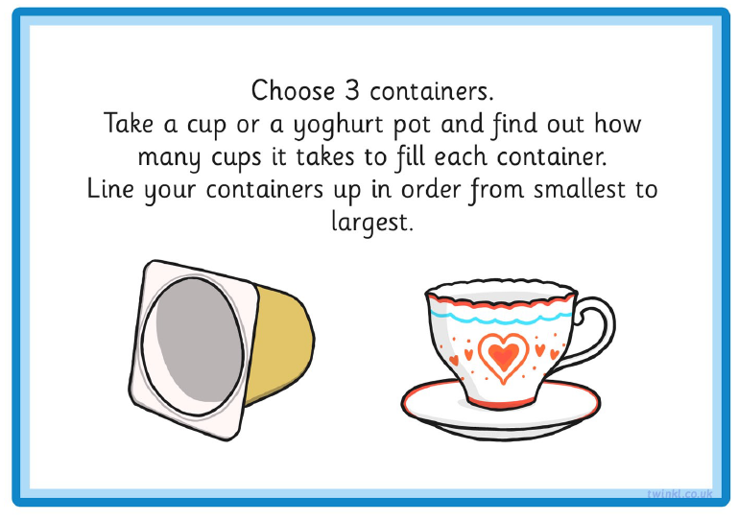  Now use the yogurt pot to see how many pot it takes to fill.  Finally line up your containers from smallest to largest. | Challenge  Does the tallest container always hold the most?  You need: a jug and five different containers which are different heights.  Now investigate  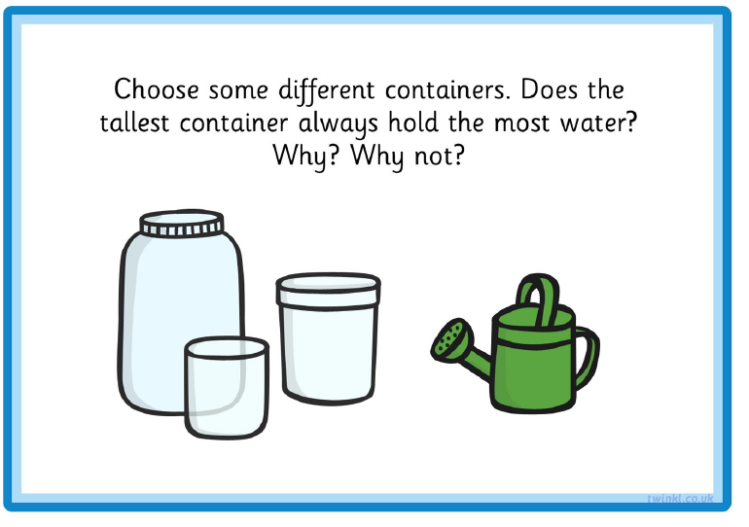
Guided reading  BUG CLUB | Can Cat get Cod? | As Monday | Can Panda Get It? | As Wednesday | Get the Map
Story  CLL | The Polar Regions/ Snow Babies  Five Little Polar Bears Rhyme (files)
Activities | Snow Babies  Watch and enjoy the Snow Babies documentary. (Only available until 1.30pm on Monday 25.1.21. Use sentences to explain what they have learnt/ enjoyed. |  |  | Enjoy looking at the Polar Bear photos from files. Can you think of some adjectives (describing words) to describe the polar bears? |  | Label the Polar Bear. (Files)  Just for fun: Can you make a book about polar bears? (Fold up a piece of a4 paper and draw some pictures/ write some words.) |  |  | Exploring The Arctic  Complete sheet (files) In the Arctic I see……… |  | Arctic Animals- What can you see? (files)  Work through the Power Point. Guess the animal. Were you right? Can you draw some pictures of some of the animals and write some captions? E.g. The husky has pointy ears.  Can you remember many of the animals have white fur and feathers?
This week we are exploring the Arctic
Afternoon  Activities |  | Arctic animal habitats  Draw your favourite animal and write words linked to it | Arctic animal and people  Animal coats- Learn about camouflage. |  |  |  | The Inuit people  Build your own Inukshuk |  |  | How does a Polar bear stay warm?  Watch this video clip  Try this experiment out!  Prompt card |  | Baby Polar Bear Dance  Enjoy and try and follow the polar bear moves!
PE links |  | Andy’s arctic workout  Creatures in the snow |  |  | Creative activities |  |  |  |  | Can you make a polar bear or arctic animal collage?  

