Lesson | Monday | Tuesday | Wednesday | Thursday | Friday
Phonics:  PM | Consolidate and apply all set 2 RWI sounds.  RWI set 2  Write a caption using red words displayed for the children to recall. Model then /I /application. | Consolidate and apply all set 2 RWI sounds.  RWI set 2  Focus on recording words on WB’s with each phoneme: ng/ nk/ ay/ee/igh/ow/oo/oo/ar/or and air. Invite children to model to the class. | Consolidate and apply all set 2 RWI sounds.  RWI set 2  Focus on letter formation of all set 2 phonemes. | Consolidate and apply all set 2 RWI sounds.  RWI set 2  Green words with focus phonemes  Read the green words and model chosen words within a sentence using red words where applicable. E.g.  He went to start the car.  All the ducks are swimming in the pond. | Consolidate and apply all set 2 RWI sounds.  RWI set 2  Jedi Handwriting  Perhaps use sugar paper and crayons to encourage orientation from shoulder.
Daily practise – saying and writing numbers to 20, counting objects, Numbots
Online videos | Exploring one more | Exploring one less | Problem solving | Colour patterns | Repeating patterns
Maths  Task | Go Fish card game  You need: digit cards to 20  Aim: to find one more  Deal the cards out to all the players.  Ask any player for a card that is one more than the one you have.  e.g. I have 5 – I need 6  Mummy have you got 6?  If you find a pair, put them face down.  The winner is the first to get rid of all their cards.  Extension - worksheet | One less Bingo  You need: a 3 by 3 grid – write any number 1-10 / 1- 20, 9 counters and digit cards 1-10 / 1-20  Aim: to find one less  Place the digit cards face down in a pile.  The Bingo caller – picks up the first card and calls it out  Players: work out 1 less and if it is on their card – place a counter on it.  The winner is the first to get:  - 3 in a row  - 4 corners  - Full house  Extension worksheets 1 and 2 | Find as many ways of making 10 using the fish activity  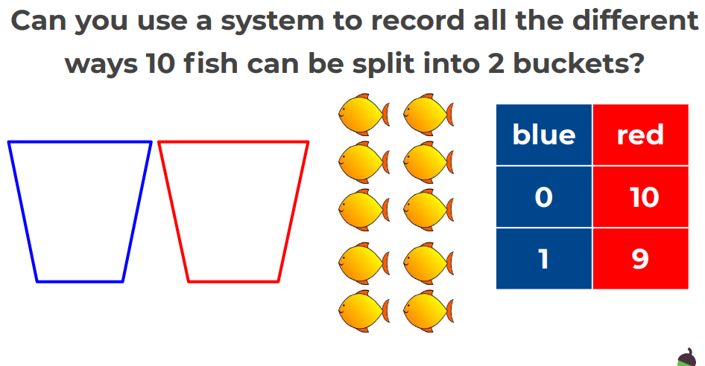  Write out a number sentence for each.  Activity | Using paint or objects  Create your own repeating patterns – try these pattern structures:  - ABAB  - ABB  - AAB  - AABB  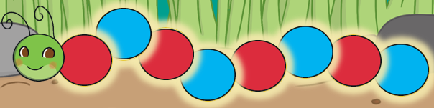  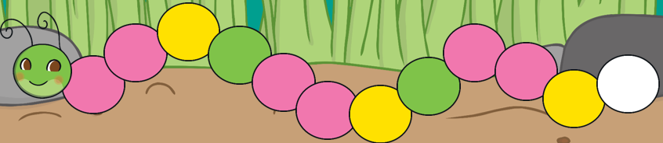 | Using the worksheets complete these patterns – watch out some are tricky!  Worksheets  Worksheet 2
Guided reading  BUG CLUB | Red level:  Go west, OX | As Monday | The Fox Twins | As Wednesday | The Quiz went fix.
Story  English | Ruby’s Worry/ We can/ The Gruffalo
English activities | Share the story Ruby’s Worry  Ruby's Worry  Can you draw a worry to describe what makes you feel a little uneasy like Ruby. |  | Reflect on the story of Ruby and her worry. What makes you feel better when you have a worry?  Write a caption:  E.g. I feel better when I have a hug with my dog. |  | Re-read The Gruffalo with the children joining in with repetition and known phrases.  PP Available from last week to share story.  Generate adjectives and a brief character description of The Gruffalo. |  | What happens at the end of The Gruffalo? Imagine if the Gruffalo caught the mouse out.  Re-write the end of the story……  E.g. The Gruffalo ate the mouse in a sandwich. |  | Can you invent a make believe story character?  Draw a picture and describe your character. Maybe it is a half character?  Half cow, half cat?
Afternoon  activities | The Gruffalo’s house  What sort of house do you think the Gruffalo lives in?  What is it made from?  Can you make a house for a Gruffalo?  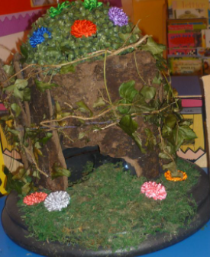 | Make Gruffalo Crumble  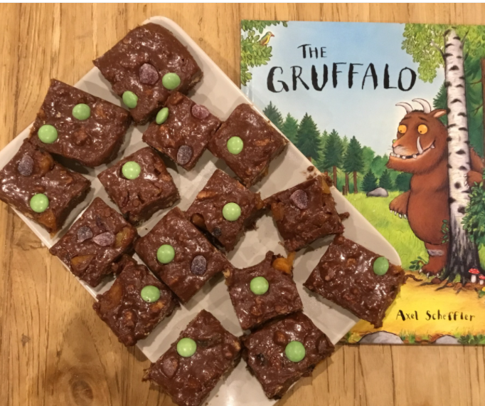  See Recipe |  | Butterfly Art Work  Using paint, tissues paper & coloured paper to make some beautiful butterflies  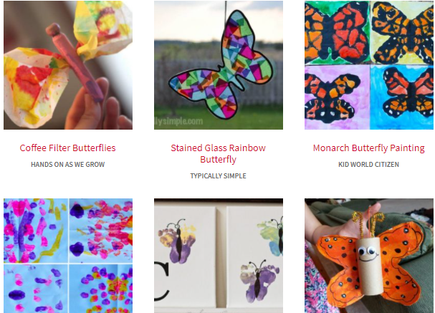 |  | Spring walk and collage  Hunt around your garden or use paper to create a spring time picture.  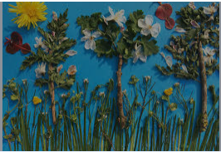 |  | Make sure Mummy is not with you!  Make a Mother’s Day card using your hand prints, and any craft materials at home  

