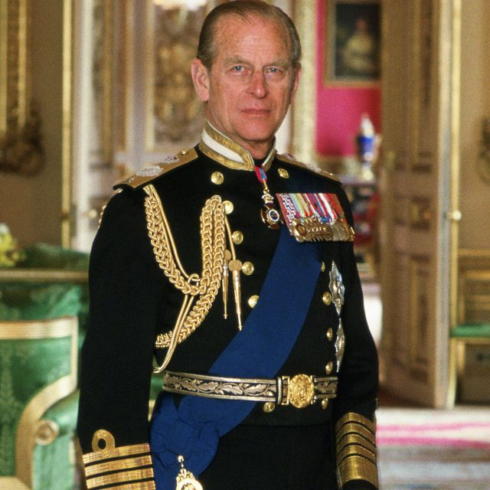
Prince Philip, Duke of Edinburgh
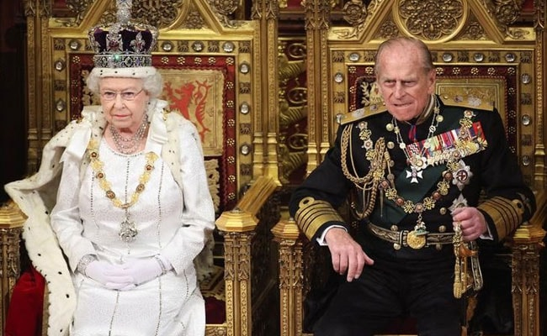
Prince Philip is married to The Queen of England.

Prince Philip was born in a country called Greece.

It is a very hot country.

Prince Philip was a sailor in The Royal Navy.
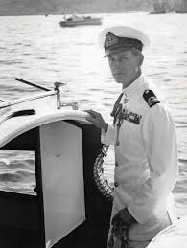
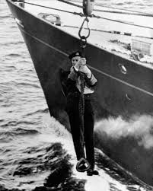
Why are the photos in black and white?
What do you think a sailor does in the Navy?
The Queen and Prince Philip have been married for a very long time. Over 70 years!

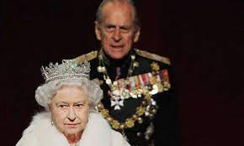

The Prince has sadly died. How do you think the Queen is feeling?

