Lesson | Monday | Tuesday | Wednesday | Thursday | Friday
Phonics: | Recap: sh/ ch/ th/ qu/ ng/ nk | RWI /ay/  Red word: so | RWI /ee/  Red word: go | RWI /igh/  Red word: all | Red word focus  RWI red words set 2
Phonics  Task | Read and race game- files  Roll the dice and read the words. Don’t forget to sound the words out like Fred! | Work through the videos on each day and pause to practise reading and writing the sound.  You will need a piece of paper or a whiteboard and something to write with.  Be prepared to pause the video to read the green words and have a go at writing the new words with the sounds in.  Extra Alphablocks videos:  ay/ Alphablocks /ay/  ee/ Alphablocks /ee/  Igh/ Alphablocks /igh/ |  |  | Watch the video and recall red words with a focus on: so, go, all.  Can you practise writing the words 3 times?  Can you challenge yourself to write a caption or sentence with each red word in it?
For this week’s maths, we are using the Teaching videos from White Rose Maths – Growing 6, 7, 8
Please use the hyperlinks to access the videos and worksheets
Daily practise – saying and writing numbers to 20, counting objects, Numbots
video | Session 1 video  Number bonds to 6 | Session 2 video  Number bonds 7 | Session 3 video  Number bonds to 8 | Numberblocks – making 10 | Numberblocks – fruit salad
Maths  Task | Teddy bear seats  You need: at least 6 of your favourite toys or teddies and up to 4 chairs.  How many ways can you put 6 teddies / toys on 2 chairs?  Can you write a number sentence to show this  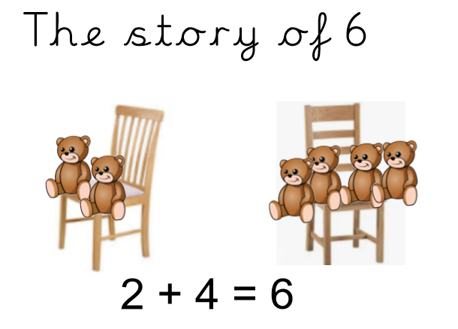  Now try 3 or 4 chairs. How many ways can you find?  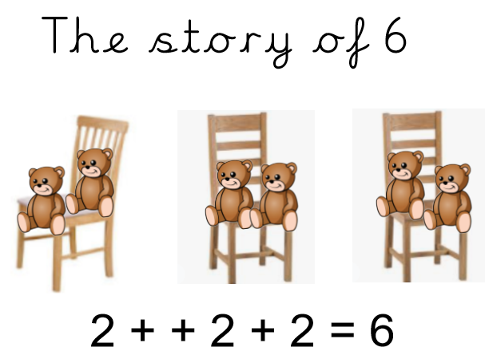  Worksheets | Domino maths  How many different ways can you arrange 7 spots on a domino?  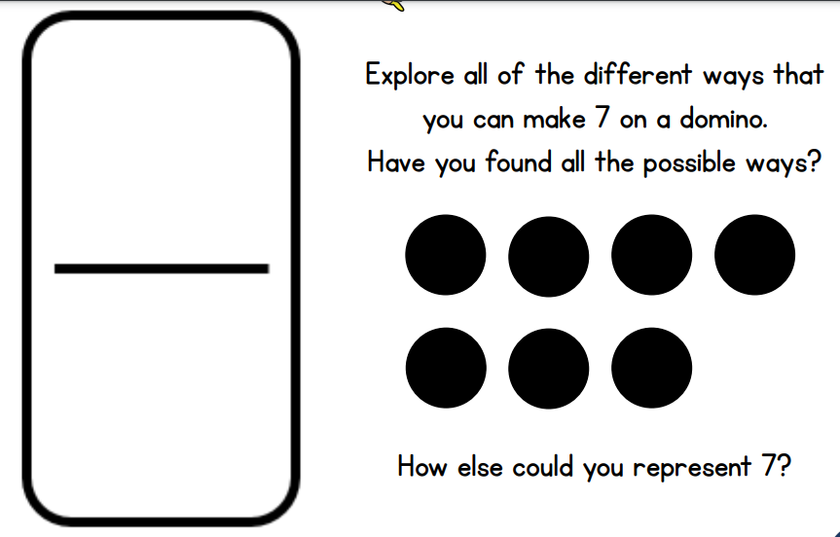  Write the number sentence for each  Now here is the challenge…  Can you write a two subtraction sentence to go with each?  Worksheets | Ladybird spots  How many different ways can you make 8  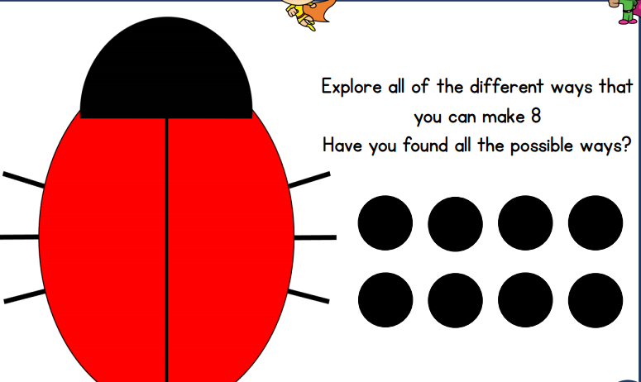  Worksheets | Unicycles, bikes and tricycles investigation.  Pip the Mechanic has counted 10 wheels in his bike shop, but he doesn’t know how many unicycles, bikes and tricycles he has– Can you help him?  Use the pictures on the sheet to find how many ways there are to make 10  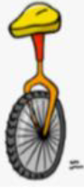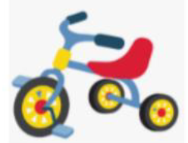  1 + 3 + 3 + 3 = 10 | Go on a number hunt around your neighbourhood  With your grown up, go out for a walk and see how many different ways you can see 6, 7 or 8.  You may see a car number plate with these numbers on – can you spot one with all the numbers on?  Can you spot a house with 6, 7, or 8 windows or find a house with that number – can you find a house with 2 of the numbers in?  There are lots of other ways to see 6, 7 and 8.  Happy hunting!
Guided reading  BUG CLUB | Top Cat | Top Cat | A Bad Lad | A Bad Lad | A Big Mess
Story  CLL | The Great Explorer- Chris Judge
CLL activities | The Great Explorer  Watch and listen to the story. Do you think you would be as brave as Tom?  Can you review the story?  - What did you enjoy about the story?  - Can you write a sentence using your phonics to describe what you liked about the story.  - Draw a picture to match your sentence. |  | The Great Explorer  What kind of character is Tom? Can you draw a picture of Tom and write some adjectives down to describe his character?  E.g. brave, sad, excited, scared |  |  | The Great Explorer  Can you listen to the story again and draw a story map of all the things Tom saw on his journey?  Try and draw a few pictures in the order they appear in the story.  Can you label your pictures? E.g. use your phonics; ice-berg/ walrus |  |  | The Great Explorer  Use your story map to write a sentence to match each part of the story; beginning, middle and end. There is a template available for you to use in the files section on teams. |  | Think about some stories you know. What do each of the stories have?  - Characters  - Settings (where the story happens)  - Something happens.  Can you imagine your own story?  Draw the character and where the story happens.  e.g. The fluffy, little penguin is playing in the blue, cold sea.  Write a sentence to match your picture so something happens.  e.g. The fluffy, little penguin was playing catch the ball with Sammy Seal in the cold, blue sea .
This week we are exploring the Antarctic!
Please use the hyperlinks to access the slides and worksheets
Afternoon  activities | Exploring the Antarctic  Using the Antarctic Explorer’s notebook – draw or write what you see! | Animals of the polar regions  Can you sort the animals into the correct polar region? |  |  | Penguin Fact file  Can you label the penguin? |  |  | Life cycle of the Penguin  Can you order the stages of the penguin? |  | Make your own iceberg experiment.  Ever fancied making your own iceberg? Now is your chance!
PE links | Frozen cosmic yoga  Winter wonderland commix yoga  Joe Wicks Active 8 workout |  |  | Creative activities |  |  | Make a hot air balloon or a boat just like Tom used to travel to The North Pole.  There are many ideas and instructions on you tube and pintrest.  Can you collage or make a penguin?  Share a rhyme and match some actions. | 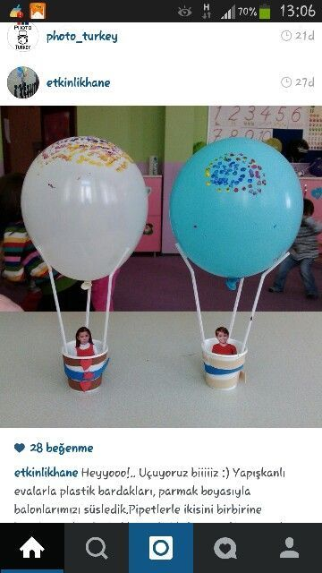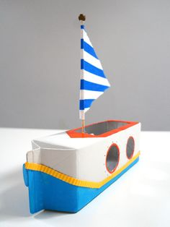  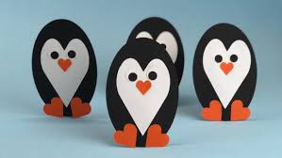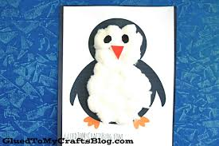  Enjoy the ‘Five Little Penguins’ song.  The Penguin Song  This is a really fun action song to enjoy.

