Lesson | Monday | Tuesday | Wednesday | Thursday | Friday
Phonics: |  |  | https://www.bbc.co.uk/iplayer/episode/b00qhslb/alphablocks-series-1-1-alphablocks-az  Revisit all the letter sounds previously learnt during the Autumn term. |  | https://www.youtube.com/watch?v=TvMyssfAUx0  Tricky words and sight words song.
Phonics  Task |  |  | Practise writing each letter of the alphabet. Can the children make a picture dictionary to match each sound? (fox can be used for the /x/ sound). |  | Share the video and remember the tricky ‘red’ words.
Maths | Use the number formation cards to practise writing the numbers 4 and 5
Maths  Task | Session 1  Sing the days of the week song  Draw 4 pictures to show what you do when you first wake up in the morning. Write a caption under each picture. | Session 2  Sing the days of the week song  Draw 4 pictures to show what you do when you go to bed. Write a caption under each picture. | Session 3  Months of the year  Get your grown up to write out the days of the week – mix then up and you put them back in order. Now for each day, think of something special you do e.g. Saturday – I go swimming | Session 4  Months of the year song  Day and night video  Fold a piece of paper in half and label one side DAY and the other NIGHT.  Now draw a picture of 5 things you do during the day and night time | Session 5  Using a timer – challenge yourself  How many times can you jump, catch a ball, write your name in 30 seconds.
Guided reading  BUG CLUB |  |  | Pink level book:  Kit’s Kit | Pop. Pop, Pop | Re-read Wednesday and Thursday’s books.
Story  CLL | We are introducing our new topic; ‘Winter’. Please use the following video to discuss the sights of winter. We will also be emailing some wintery pictures to support discussion.  Walking in a snow forest : https://www.youtube.com/watch?v=EsPMpFKvZIA
Activities | Look through the pictures and winter scenery videos. What words can the children think of to describe what they’re seeing. Are they able to use their phonics to record some words. E.g. Sound out cold (like Fred) c-o-l-d/ h-a-t  Can you make a winter jar? We are exploring all things wintery. This is a fun activity to share with your child and we would really love to see some photos of the children’s creations. Here are a few ideas but glitter and cotton wool may be useful!  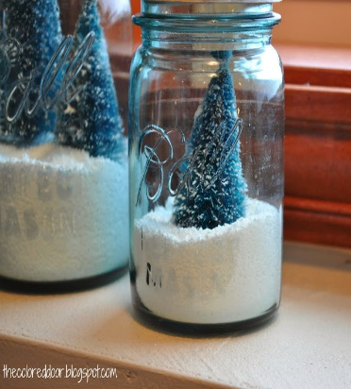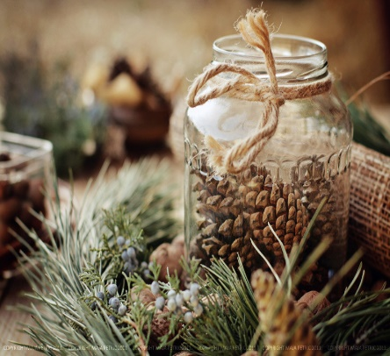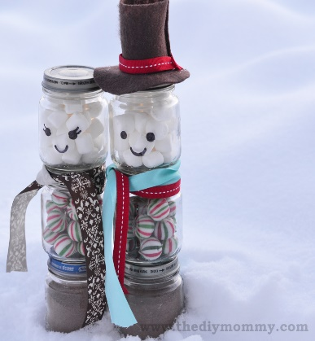  This Photo by Unknown Author is licensed under CC BY-SA-NC

