Lesson | Monday | Tuesday | Wednesday | Thursday | Friday
Phonics: | Set 1 and 2 with Miss Carter.  Red word reading | /ar/  Start the car  Red word : her  /ar/ Alphablocks | /or/  Shut the door  Red word: call  Additional: /or/ Alphablocks | /air/  That’s not fair  Red word: want  Additional: /air/ Alphablocks | Jedi Handwriting  It’s Friday so lets practise writing our letters! White boards at the ready!
Phonics  Task | Make the phonics cube with focus sounds : ay/ ee/ oo/oo/ow/igh  Roll the cube. Can you say and write a word which has that sound? | Watch the video and learn this new digraph.  Try to colour in and read the /ar/ words in our phoneme spotter story. | Work through the video reading the green words and writing the /or/ words given.  Read and roll game :/or/ | Learn about the trigraph /air/. White boards at the ready!  Read the green words and write down the words with the sound /air/.  Real and nonsense words /air/ | Letter formation sheet. Try and write over these letters starting in the correct places.
Online videos | Numberblocks 9 | Numberblocks 10 | Numberblocks – making 10  Number bonds  Making 10 session 4 video | Comparing numbers  Session 2 video | Comparing numbers in 10 session 3 video
Maths  Task | Making 9 and 10  Investigate how many different ways can you make 9 and 10  You need:  - A tens frame  - 2 different types of objects  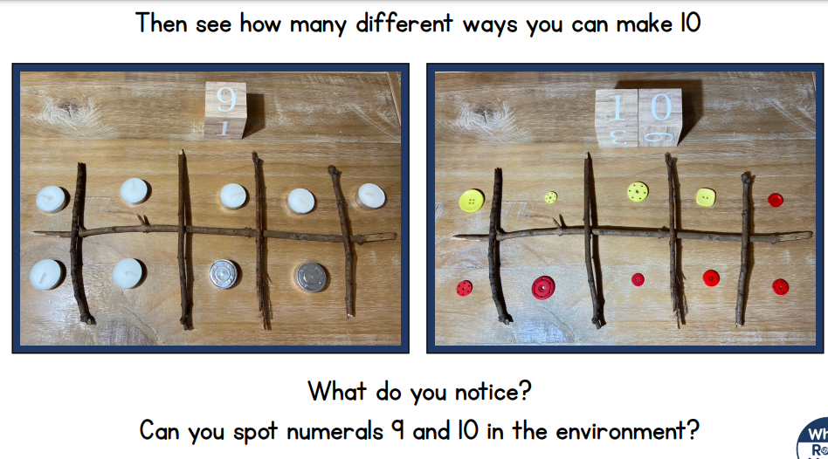  Now arrange the objects in the tens frame to find all the bonds for 9 and 10. For each, write a number sentence.  3+ 6 = 9 | Game Day  Print off set 1 and set 2 or make two sets of cards showing the numbers 1-10 on tens frames.  Game 1 Pairs game  Lay all the cards face down  Take it in turns to turn over two cards.  When you find a pair adding to 10, you keep the cards.  The player who collects the most pairs wins!  Game 2 – Go fish ( 3 / 4 players)  Aim – make bonds to 10  Deal all the cards out to the players  Take turns to ask any player for a card you need. E.g. if you have a 4 – you need to ask for a 6  Once you have a pair – place in on the floor/table.  The first person to put down all their cards is the winner. | Number bond hunt  Using the worksheets – can you pair up the two cards that make 10.  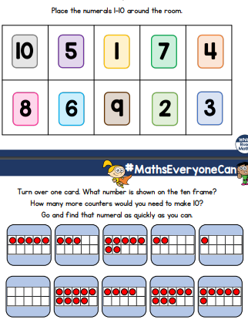  Can you make your own game for number bonds to 20?  Why not play ‘Hit the button’ | More / less  You will need:  - Pasta / coins/ cubes  - A bag  We are looking at comparing who has most/ more and who has less/ fewest. To extend this, you could work out the difference between the two groups.  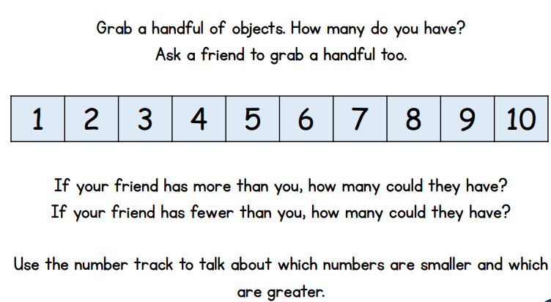  I have 7, you have 4. The difference between 7 and 3 is 3 7 – 4 = 3 | More or Less  If you have your own dominoes use those, if not use the worksheet.  Pick a domino – can you now find one with:  - Fewer spots  - More spots?  Can you now work out the difference between the two numbers  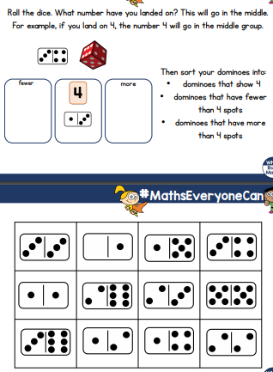  ‘My number is 4. 3 is less than 4. And the difference between the two numbers is 1’  Extensions  - Play the game with numbers up to 20! Make digit cards 1 to 20 and use these 10s frame numbers
Guided reading  BUG CLUB | Sid and Duck | As yesterday | Sid’s Pet Rat | As yesterday | The Bop
Story  CLL | The Gruffalo  World Book Day- Thursday 4th March
CLL activities | The Gruffalo Story  Make some story characters or cut out the role play masks from our resources section. | Gruffalo drama lesson  Imagine being in the deep, dark wood. Can you pretend to be the characters during this lesson? | World Book Day competition activity:  Share The Gruffalo story on the PP. Focus on the descriptions. What is The Gruffalo like? Is he mean? Grumpy? Kind? Friendly?  - Imagine The Gruffalo was at the top of the beanstalk which Jack (From our story Jack and the Beanstalk) grew. Imagine the two characters bumped into each other. What might they say to each other?  Create a story picture of the two characters. Can you write a sentence from each character as if they were having a conversation?  There is a template on the remote learning page but feel free to paint, draw or crayon your characters and write your own speech bubbles.  Please send photos of your child’s work to BusyBessBTP@welearn365.com so we can forward your competition entries.  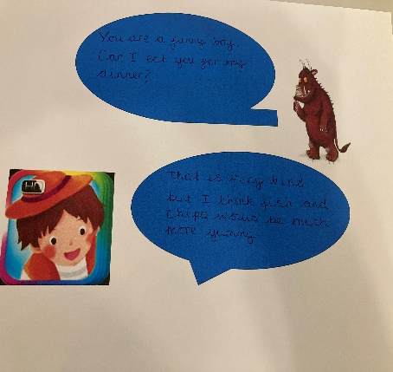 |  |  | World Book Day  Celebrate and enjoy your favourite books. Listen to stories and discuss your favourite characters.  - Can you draw a picture from your favourite story?  - Write a caption or sentence about the story and why you like it. | Re-read the story of The Gruffalo. Cut out the characters to create a story map. There is a map available for you to talk your ideas through in the resources section.  Use some sequencing words to retell the story from your map.  -next  Then  After that  Share your story maps.
Afternoon  activities | Make your own Gruffalo  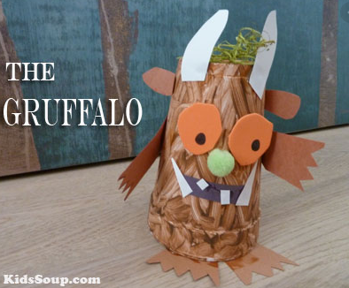 | Make a Gruffalo mask!  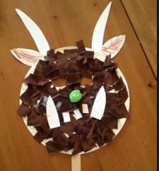 | Make Gruffalo Paws  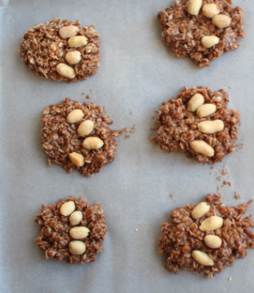  See the recipe |  |  | Design your own woodland creature!  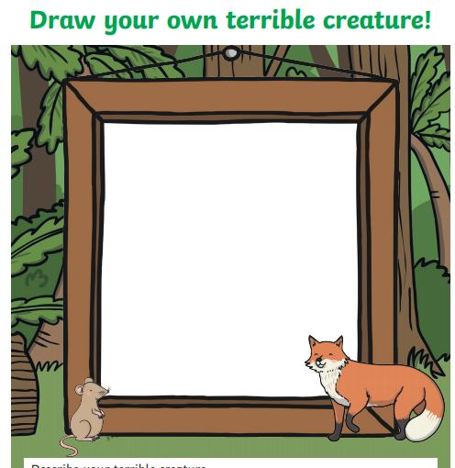  Frame | Woodland walk Scavenger hunt.  Are you brave enough to take a walk in the woods?  How many of these can you tick off on your walk?  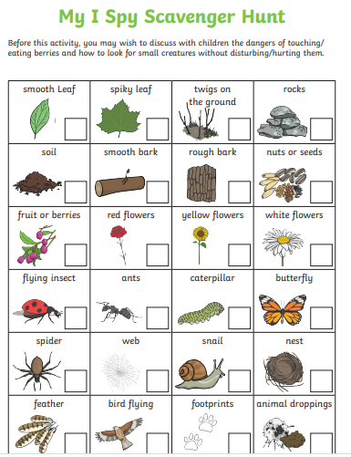  Checklist
PE links | Andy’s wild workout – undergrowth  Andy’s wild workout – Rain forest  A-Moose-Ta-Cha - Moose Tube | GoNoodle |  |  |  | Music: Have a little fun with this singing and clapping activity.  clapping and singing fun  Story time, music and actions session: The Gruffalo Story and actions to music: The Gruffalo

