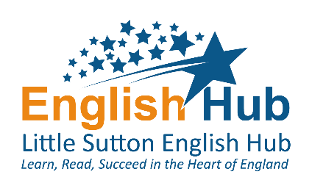


Online phonics lessons for Letters and Sounds

We are pleased to announce, from Monday 27 April, online phonics lessons are available from Letters and Sounds for home and school


Written and presented by phonics experts and funded by the Department for Education, the online lessons are designed to cover new phonics teaching that children would have received over the summer term had they been in school. This resource is for use by teachers and parents who will find planning and teaching phonics challenging when schools are closed due to Covid-19.

Three sets of lessons will be available. One set for Reception and one for Year 1, based on where children are expected to be in their learning by the summer term. A third set of lessons aims to reach the children in Reception who need more practise with their blending. A guidance film for parents to explain the basics of Phonics and how parents can support their child is also available.
From Monday 27 April, a new lesson will be uploaded Monday to Friday at the times below during the summer term. *After upload, each lesson will then be available to watch throughout the summer term.

11 am* | Learning to blend  Phase 2 recap | For children in Reception and Year 1 who need extra practice sounding and reading words such as ‘tap’ ‘cap’ ‘mat’ ‘pat’

10 am* | Reception Summer term  Phases 3 & 4 | For Reception children who can blend and read words such as ‘fish’ ‘chat’ and ‘rain’

10:30 am* | Year 1 Summer term  Phase 5 | For Year 1 children who can confidently blend and read words such as ‘stamp’ ‘chair’ and ‘green’

How to let your parents know
To help you to communicate this new resource, a letter is attached to this email for you to send to parents. Your school may want to add additional guidance for their parents to help them to select the set of lessons most appropriate for their child’s stage of phonics learning. We also encourage you to add this announcement to your website and to tweet about it. We have attached a pack for this purpose; you just need to add the hyperlink https://bit.ly/34KsiFS to your tweet.

To support schools in keeping children safe online, DfE have provided safeguarding guidance

We hope you will find this new Letters and Sounds resource a useful addition to support your school and parents during this unprecedented time.

