Design and Build Your Own Rollercoaster
Test Stages
Complete the table below with the materials you are testing and notes on how they perform in the test.

Material | What was it good at? | What was it bad at?

Complete the table to show which materials you will use for the different features.

Feature | Best material | Notes/things to think about
360° loop
45º drop
High section at 50cm or above

Design
Use this space to design your rollercoaster.
You will need to include labels for each part and notes of measurements as well as materials.

Evaluation
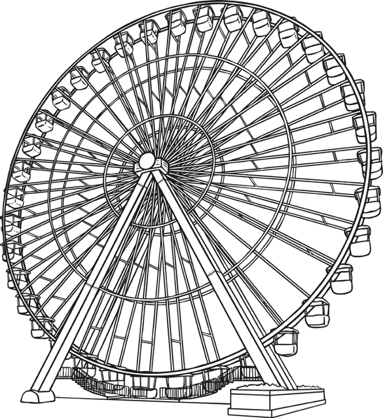
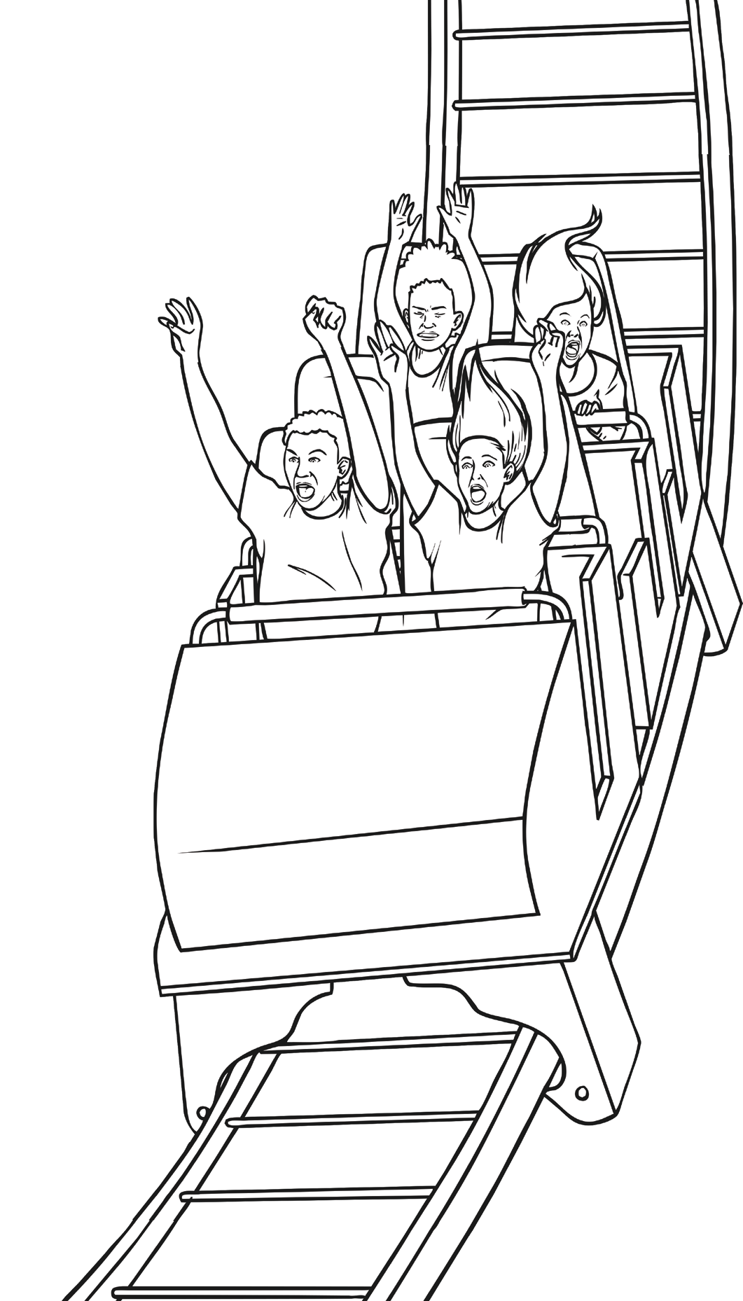
Tick the features you included:
45° drop
360° loop
High section at 50 cm above
Full length at least 50cm
What worked well and why?
What didn’t quite work and why was this?
If you were to build this again what would
you change?

What did you like from other people’s designs?

Do you think you would like to be a rollercoaster designer and why?

